

Content Author Guide

October 22, 2018

|  |  |  |
| --- | --- | --- |
| **Version** | **Date** | **Notes** |
| 1.0 | 10/22/2018 | Initial Version |

**Table of Contents**

Header Renderings 5

Header 5

Utility Brand Bar 9

Components Feature 12

Anchor Bar 12

Composite Content Card 13

Content Panel 14

Expandable Callout 14

Expert 15

Expert Callout 15

Featured Products and Solutions 16

Flare List 17

Generic Callout 18

Header Large 18

Header Left Panel 20

Home Image Grid 21

Home Inpage Banner Rendering 24

Home Two Column Flare Rendering 24

Icon List 26

Image Gallery 26

Image with content 27

Jumbo Header 30

Key Action 31

Related Offerings Card 31

Related Offerings Section (And Sublayout) 33

Small Header 34

Solution Card 35

Solution Card List Update 36

Tab Control and Tab Panel 36

Technical Support Panel 37

Text List Rollup 39

Text Table 40

Video Anchor Button 41

Video Display 42

Events Feature 44

Download 44

Event By Line 45

Event Detail 46

Event Header 47

Featured Event (or Webinar) 48

Hosted By 49

Upcoming Events 50

Webinar Detail 51

Webinar Header 52

Landing Header 53

Insights Feature 54

Featured Insight 54

Insight About the Author 54

Insight At A Glance 56

Insight By Line 58

Insight Data Callout 1 Column 58

Insight Data Callout 2 Column 59

Insight Data Callout Small 60

Insight Header 62

Insight Highlight 62

Insight Panel Rendering 63

Insight Quilt Dynamic and Insight Quilt Dynamic Slim Renderings 64

Insight Quilt Static and Insight Quilt Static Slim Renderings 65

Insight Rich Texts 66

Insight Sublayout 68

Insight Summary 68

Locations Feature 69

Key Action Location Finder Callout Rendering 70

Local Page Detail 72

Location Finder Callout Rendering (Partner Finder Callout) 74

Location Finder Results Rendering 75

Navigation Feature 77

Brand Grid Dynamic 77

Brand Grid Static 78

Brand Grid with Description 80

Breadcrumb 81

Cookie Disclaimer 82

Gated Content Modal 83

Global Alerts Banner 85

Footer Renderings 86

Footer 86

# Header Renderings

## Header

|  |  |
| --- | --- |
| Datasource Template | /sitecore/templates/Feature/Navigation/Header/Header |
| Datasource Location | /sitecore/content/<Site>/Site Shared Content/Site Headers |
| Rendering | /sitecore/layout/Renderings/Feature/Navigation/Header/Universal Header |

### Prerequisites

The following items must be present in Sitecore to complete the steps described below:

1. /sitecore/content/<Site>/Site Shared Content/Site Menus

2. /sitecore/content/<Site>/Site Shared Content/Site Headers

3. /sitecore/content/<Site>/Site Settings

### Appearance



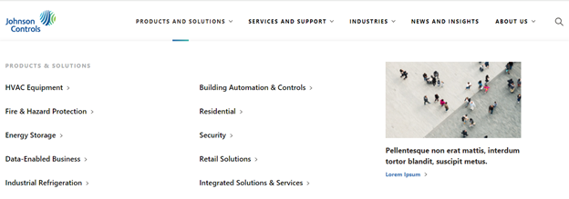

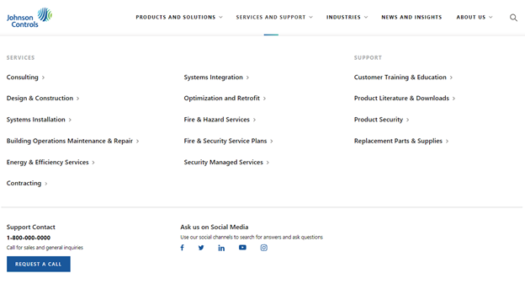

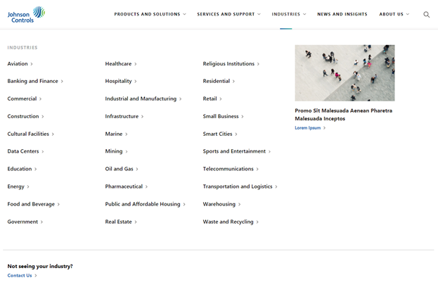

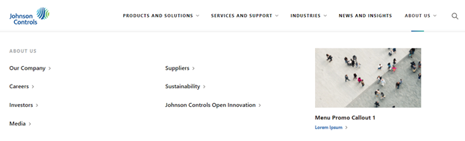

### Create the Datasource

1. Login to Sitecore

2. Open the **Content Editor**

3. Expand **Content**

4. Expand the Site under which you want to create the new Header

5. Expand **Site Shared Content**

6. Right-click **Site Headers**

7. Click **Insert**

8. Click **Header**

9. Enter the name of the item and click the **OK** button

### Create the content

#### Menus

The **Header** is composed of Menus. Menus are layed out in three formats:

1. Menu Option 1 – No Mega Menu

* 1. Example: News and Events

2. Menu Option 2 – Two Rows – 8x4 and 4x4x4

* 1. Example: Services and Support

3. Menu Option 3 – Two Rows – 8x4 and 12

* 1. Example: Industries

To create a Menu:

1. Right-click the **Site Menus** folder

2. Click **Insert**

3. Click on the Menu option you want to create

4. Enter the name of the item and click the **OK** button

5. Set the **Link** field

6. Save the item

If you selected Option 2 or Option 3, you will be able to add components to the Menu.

##### Universal Menu Link List

One of the components you can add to the Menu is the **Universal Menu Link List**. To add this component to the Menu, you need to first create the content for this component. Follow the steps in the **JCI - Content Author Reference Doc - Universal Menu Link List** document to create the content for your **Universal Menu Link List** components.

##### Social Media Callout

Another component you can add to the Footer is the **Social Media Callout**. Follow the same steps as the **Universal Menu Link List** to create the content for the **Social Media Callout**.

Now that you’ve created all of your **Menu Link Lists** and **Social Media Callout** items, you need to add **Universal Menu Link List** components to the Menu and associate them with your link lists. During this time, you will also add other components to your Menus and create additional content.

1. Click on the Menu item you created a few steps above

2. Go to the **Publish** tab

3. Click **Experience Editor**

The Menu item will open in the Sitecore Experience Editor.

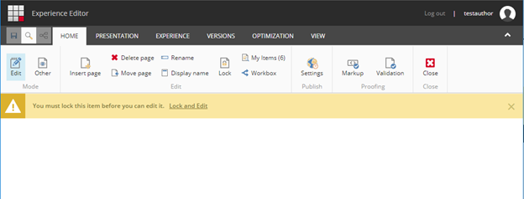

4. Click **Lock and Edit**

You will now see placeholders for each section of the Menu where you can add components.

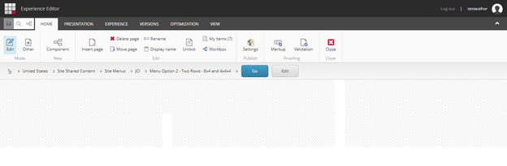

To add components to a placeholder:

1. Click anywhere inside the placeholder

2. Click the **+ Add here** button that displays in the top-level of the placeholder

3. Select the component you want to add

4. Click the **Select** button

5. Either select an existing content item from the list on the right or click **Create New Content**

* 1. If you clicked **Create New Content**, enter the name of the item and click the **OK** button

Repeat steps 1 through 5 above for each component you desire to add to the menu.

Once you’ve added all of your components to the menu, click the **Save** button in the top-left.

#### Finalizing the Header content

Now that you’ve created all of your Menus, you need to select them in the **Header** item and place them in the order you’d like as well as define the rest of the content of your **Header**.

1. Go to the **Header** item you created under section 1.3 Create the Datasource

2. In the **Menus** field, select the Menus and order them as you’d like

3. In the **Logo** field, select the logo for your site

4. In the **Logo Link** field, insert a link to the page to which you want to link from the logo

5. Save the item

### Set the default Header

Now that you’ve created the new **Header**, you have to set it as the “default” Header for your site(s).

1. Go to the **Site Settings** item for your site(s)

2. In the **Default Header** field, select the new Header you created in the above steps

3. Save the item

### Preview the Home page

Preview the Home page for the Site in which you set the new Header. Your new Header will display at the very top of the page.

### Update an existing Header

1. Login to Sitecore

2. Open the **Content Editor**

3. Expand **Content**

4. Expand the Site under which you want to update the Header

5. Expand **Site Shared Content**

6. Expand **Site Headers**

7. Click on the Header you want to update

* 1. If you want to edit the content that was previously created
  2. Go to the **Publish** tab
  3. Click **Experience Editor**
  4. Update the content as desired
  5. Save the item

1. If you want to create new content or delete content that was previously created
   1. Follow the steps in section 1.4 Create the content

## Utility Brand Bar

|  |  |
| --- | --- |
| Datasource Template | /sitecore/templates/Feature/Navigation/Utility Brand Bar/Utility Brand Bar |
| Datasource Location | /sitecore/content/Global Content/Global Utility Brand Bars |
| Rendering | /sitecore/layout/Renderings/Feature/Navigation/Utility Brand Bar/Universal Utility Brand Bar |

### Prerequisites

The following items must be present in Sitecore to complete the steps described below:

1. /sitecore/content/Global Content/Global Brands

2. /sitecore/content/Global Content/Global Utility Brand Bars

3. /sitecore/content/<Site>/Site Settings

### Appearance



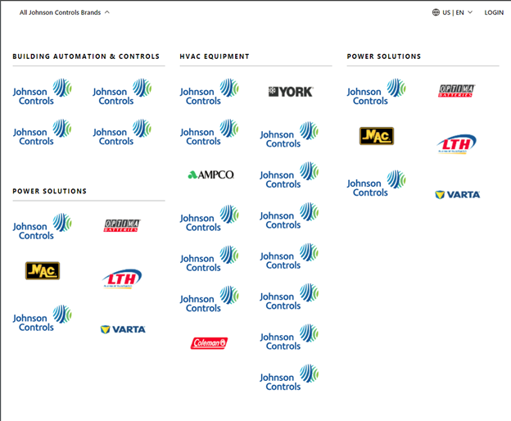

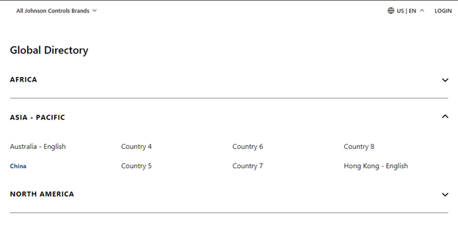

### Create the Datasource

1. Login to Sitecore

2. Open the **Content Editor**

3. Expand **Content**

4. Expand **Global Content**

5. Right-click **Global Utility Brand Bars**

6. Click **Insert**

7. Click **Utility Brand Bar**

8. Enter the name of the item and click the **OK** button

You should now see an item similar to this:

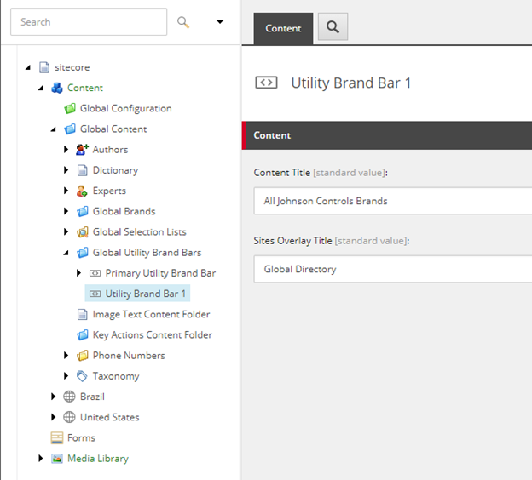

### Create the content

#### Brand Lists

1. Expand the new **Utility Brand Bar** you created in the previous step

2. Right-click the **Brand Lists** folder

3. Click **Insert**

4. Click **Brand List Column**

5. Enter the name of the item and click the **OK** button

6. Right-click the **Brand List Column** item you created in the previous step

7. Click **Insert**

8. Click **Brand List**

9. Enter the name of the item and click the **OK** button

10. Select the desired brands in the **Selected Brands** field

11. Save the item

12. Repeat steps 2 through 11 for the remaining Brand Lists

#### Site Items Lists

Each **Site Items Lists** item represent a continent. Each **Site Item** item below a **Site Items List** item represents a country/geo.

1. Right-click the **Site Items Lists** folder

2. Click **Insert**

3. Click **Site Items List**

4. Enter the name of the item (likely, the name of a continent) and click the **OK** button

5. Repeat steps 1 through 4 for the remaining Site Items Lists

After you’ve created the Site Items Lists items, to create the Site Item items:

1. Right-click the **Site Items List** item

2. Click **Insert**

3. Click **Site Item**

4. Enter the name of the item (likely, the name of a country) and click the **OK** button

5. Repeat steps 1 through 4 for the remaining Site Item items

For each **Site Item** item:

1. Enter the **Abbreviation**

2. Insert a link to the Home item for site or insert the external link to an external site

### Set the default Utility Brand Bar

Now that you’ve created the new **Utility Brand Bar**, you have to set it as the “default” Utility Brand Bar for your site(s).

1. Go to the **Site Settings** item for your site

2. In the **Default Utility Brand Bar** field, select the new Utility Brand Bar you created in the above steps

3. Save the item

### Preview the Home page

Preview the Home page for the Site in which you set the new Utility Brand Bar. Your new Utility Brand Bar will display at the very top of the page.

### Update an existing Utility Brand Bar

1. Login to Sitecore

2. Open the **Content Editor**

3. Expand **Content**

4. Expand **Global Content**

5. Expand **Global Utility Brand Bars**

6. Click on the Utility Brand Bar you want to update

7. Follow the steps in section 1.4 Create the content

# Components Feature

## Anchor Bar

|  |  |
| --- | --- |
| **Rendering** | /sitecore/layout/Renderings/Feature/Components/Universal Anchor Bar |
| **Data Sources** | /sitecore/templates/Feature/Components/Universal Anchor Bar/Universal Anchor  /sitecore/templates/Feature/Components/Universal Anchor Bar/Universal Anchor Bar |

The anchor bar rendering displays a list of links that can be used to quickly jump to an invisible anchor rendering somewhere in the page. It also has a title and a button link.

The **anchor bar rendering**:



The **anchor bar datasource**:

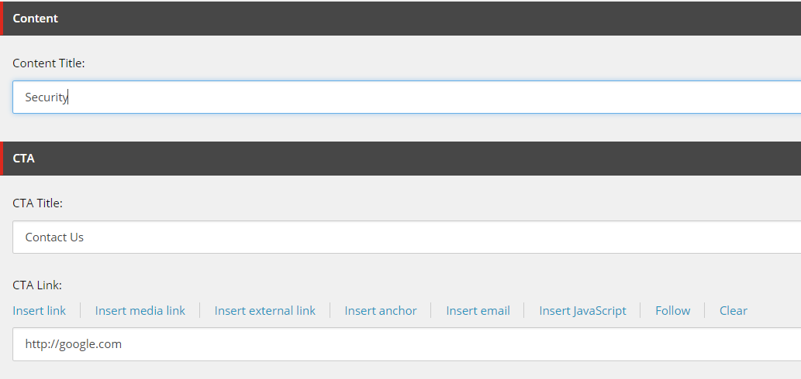

**Content Title** controls the text on the left of the anchor bar. **CTA Title** and **CTA Link** control the text and URL of the button on the right.

The links in the anchor bar are all children of the datasource item. Each child has a **Content title**, which controls the actual text of that link, and an **Anchor Name**, which is not displayed to the user but is used to locate the anchor location in the page. The Anchor Name should be unique among other anchors on the page.

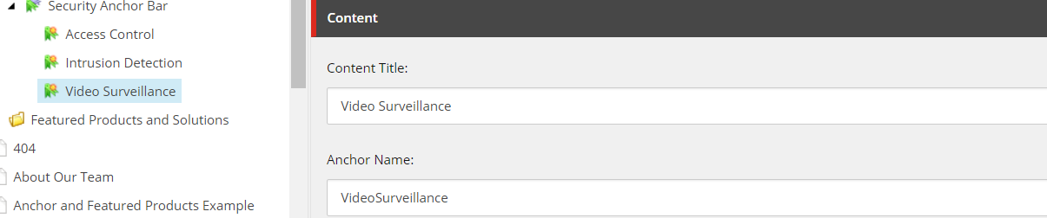

The **anchor rendering** itself is invisible. It takes one of the anchor children from the anchor bar as a datasource. When an anchor bar and a corresponding anchor are on the same page, clicking the link in the anchor bar will position the user’s browser at the anchor.

## Composite Content Card

|  |  |
| --- | --- |
| **Rendering** | /sitecore/layout/Renderings/Feature/Components/Composite Content Card |
| **Data Source** | /sitecore/templates/Feature/Components/Composite Content Card/Composite Content Card |

The composite content card allows you to add a title (single line text), text (rich text) and a link list title (single line text).

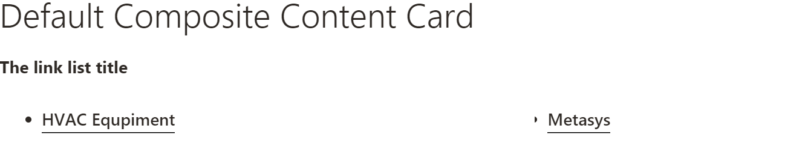

The rendering takes a Composite Content Card as a data source.

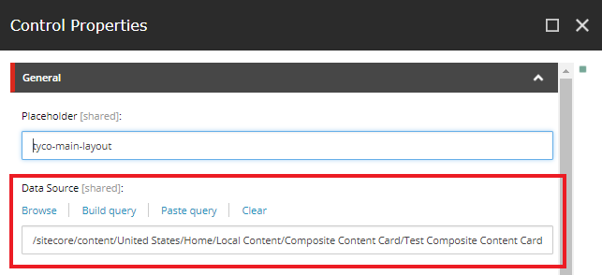

## Content Panel

|  |  |
| --- | --- |
| **Rendering** | /sitecore/layout/Renderings/Feature/Components/Content Panel |
| **Data Source** | /sitecore/templates/Feature/Components/Content Panel/Content Panel |

Content panel itself doesn’t render on the page but is a container for other components. There are several options for layout of the content panel:

* Full Width (no sublayout)
* Content Panel Sublayout 5x7
* Content Panel Sublayout 6x6
* Content Panel Sublayout 7x5

## Expandable Callout

|  |  |
| --- | --- |
| **Rendering** | /sitecore/layout/Renderings/Feature/Components/Expandable Callout |
| **Data Source** | /sitecore/templates/Feature/Components/Expandable Callout/Expandable Callout |

Excpandable callout displays collapsed and upon expansion shows a link list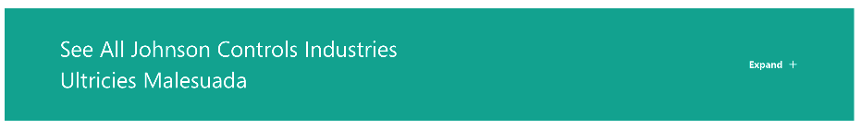

Expanded:

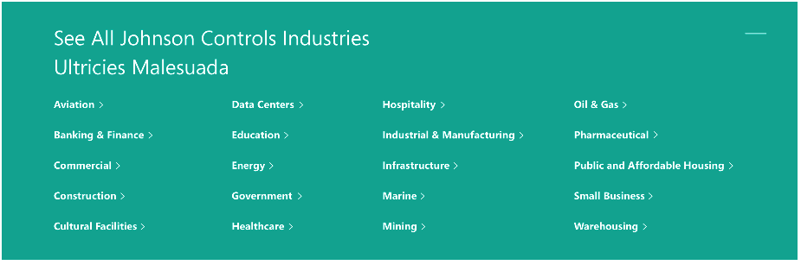

## Expert

|  |  |
| --- | --- |
| **Rendering** | /sitecore/layout/Renderings/Feature/Components/Expert |
| **Data Source** | /sitecore/templates/Feature/Components/Expert Callout/Expert |

Experts are created to be reused by expert callouts.

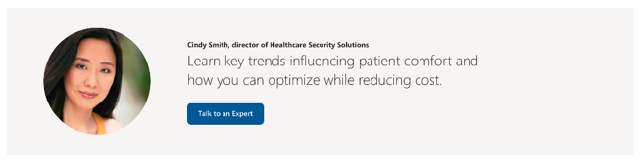

## Expert Callout

|  |  |
| --- | --- |
| **Rendering** | /sitecore/layout/Renderings/Feature/Components/Expert Callout |
| **Data Source** | /sitecore/templates/Feature/Components/Expert Callout/Expert Callout |

The expert callout rendering links to an Expert rendering to provide information about relevant thought leaders for a given page.



## Featured List and Featured List Card

|  |  |
| --- | --- |
| **Renderings** | /sitecore/layout/Renderings/Feature/Components/Featured List/Featured List  /sitecore/layout/Renderings/Feature/Components/Featured List/Featured List Card |
| **Data Sources** | /sitecore/templates/Feature/Components/Featured List/Featured List  /sitecore/templates/Feature/Components/Featured List/Featured List Card |

### Create the Datasource

Create a new item from the **Featured List** template. This item controls the heading text above the list.

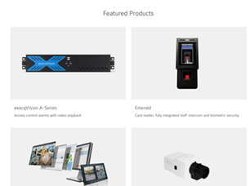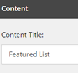

For each card you want to display, create a **Featured List Card**. This controls the text, hover accent color, and image for each individual card.

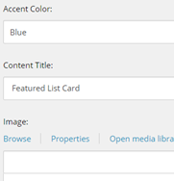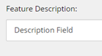

### Associate the content

Using either the experience editor or the presentation details menu, add a **Featured List** rendering to a page and then associate its datasource to the item you created earlier. This will also expose a placeholder to add **Featured List Card** renderings which you should associate to the card items you made earlier.

## Featured Products and Solutions

|  |  |
| --- | --- |
| **Rendering** | /sitecore/layout/Renderings/Feature/Components/Featured Products And Solutions |
| **Data Sources** | /sitecore/templates/Feature/Components/Featured Products and Solutions/Featured Data List  /sitecore/templates/Feature/Components/Featured Products and Solutions/Featured Data Item  /sitecore/templates/Feature/Components/Featured Products and Solutions/Featured Data Link |

A Featured Products and Services rendering allows you to highlight up to four featured links, and any links associated to them.

The **featured products and services rendering**:

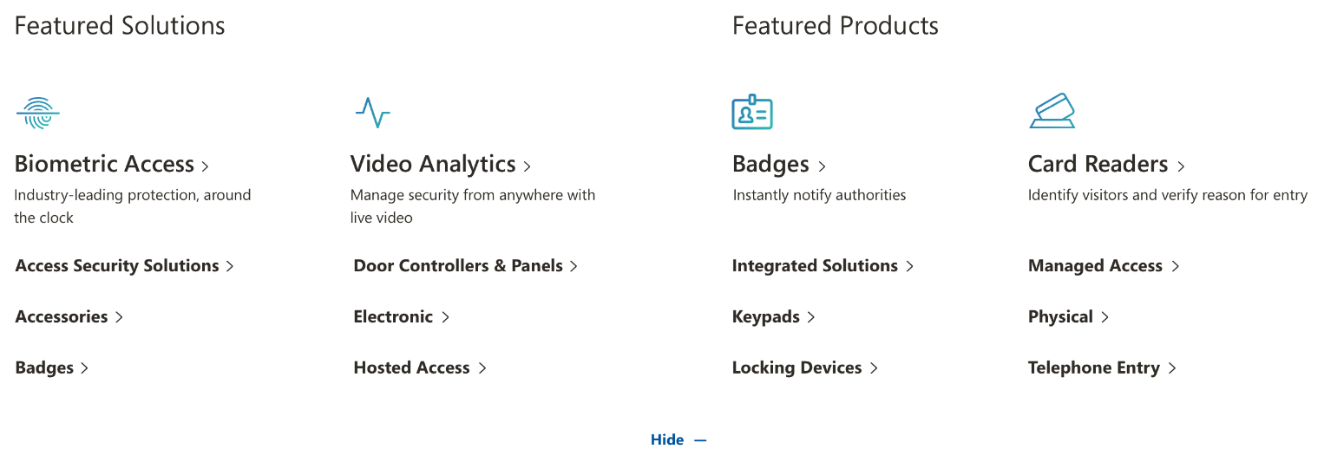

The rendering takes a **Featured Data List** as a datasource. The list itself has no fields to display, but it contains a collection of **Featured Data Items**. Up to four of these items can be displayed in a rendering. Each data item contains fields for that feature.

A featured data list called “Test Collection”, containing featured data items. Highlighted is the Biometric Access featured data item.

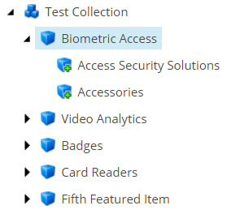 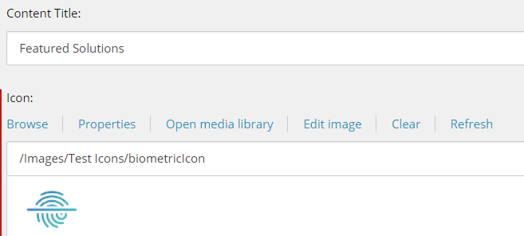

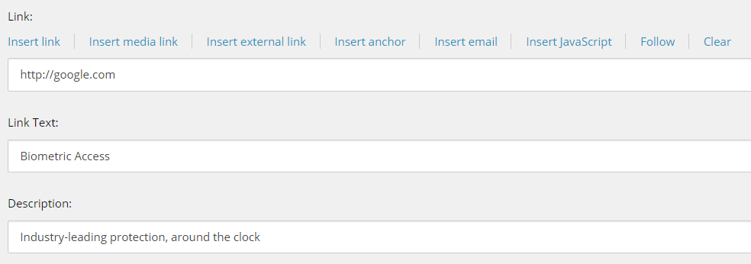

**Content Title** is optional and controls the text above the feature. In the screenshot above, only the first and third items have a content title.

The **icon** field controls the image.

**Link** and **Link Text** control the large clickable text below the image.

**Description** controls the short text below that link.

The links below the description are hidden by default. The show/hide button will reveal or conceal links for all features. The links themselves are children of the Featured Data Item, called **Featured Data Links**.

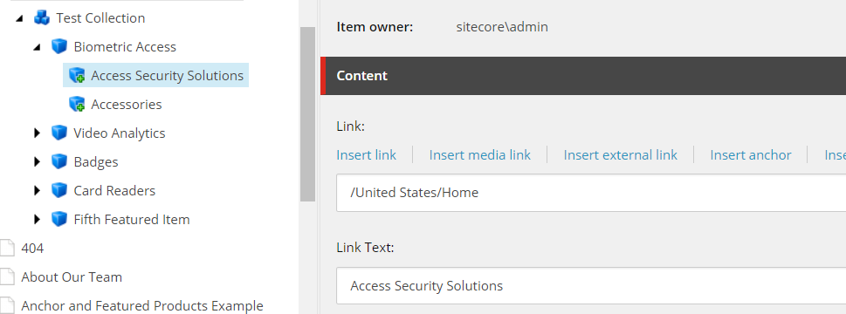

**Link** controls the URL, and **Link Text** controls the text of each of these links.

## Flare List

|  |  |
| --- | --- |
| **Rendering** | /sitecore/layout/Renderings/Feature/Components/Flare List |
| **Data Source** | /sitecore/templates/Feature/Components/Flare List/Flare List  /sitecore/templates/Feature/Components/Flare List/Flare List Item |

Flare list is a component to allow for links and descriptions to resources on the site.

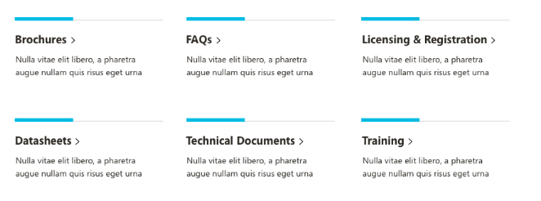

## Generic Callout

|  |  |
| --- | --- |
| **Rendering** | /sitecore/layout/Renderings/Feature/Components/Generic Callout |
| **Data Source** | /sitecore/templates/Feature/Components/Generic Callout/Generic Callout |

The **Universal Generic Callout** rendering lets you display a short text description next to a linking button.

The rendering uses a **Generic Callout** datasource, which controls the text and the link.

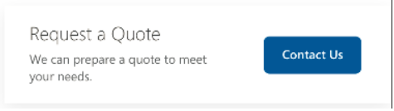

## Header Large

|  |  |
| --- | --- |
| **Rendering** | /sitecore/layout/Renderings/Feature/Components/Header |
| **Data Source** | /sitecore/templates/Feature/Components/Header/Header Data |

The header large displays a large title, with optional image or colored background and CTA button.

There are two options for the header

Universal Large



Universal Medium



The **Content Title** controls the h1 text of the header, while the **Title Color** controls its color.

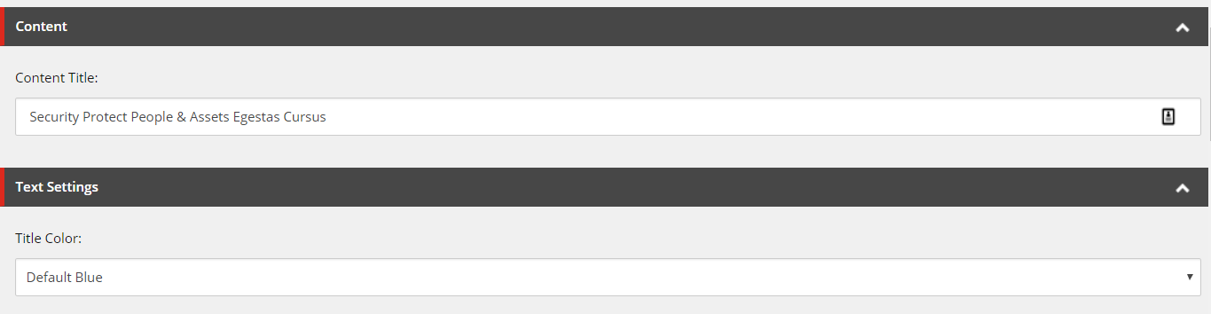

The **Background Image** controls the image behind the title. If no image is specified, the background will be a solid block of the color specified by **Background Color**. If there is an image, background color is not used.

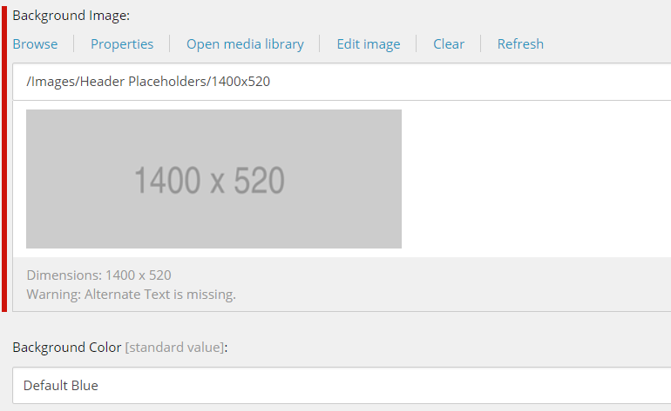

The optional CTA button, seen in the second screenshot of the rendering at the top, is only displayed if a **Link** and **Link Text** are defined. The **Button Color** controls the color of the CTA background, and **Text Color** controls the text color itself.

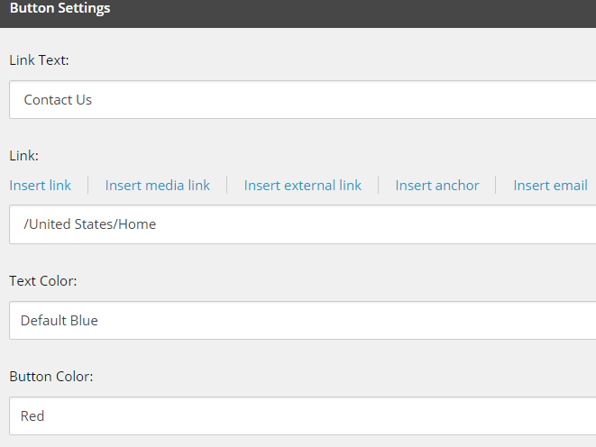

## Header Left Panel

|  |  |
| --- | --- |
| **Rendering** | /sitecore/layout/Renderings/Feature/Components/Header Left Panel |
| **Data Source** | /sitecore/templates/Feature/Components/Header Left Panel/Header Left Panel |

Header left panel is used as a visual callout to the left of a content element.

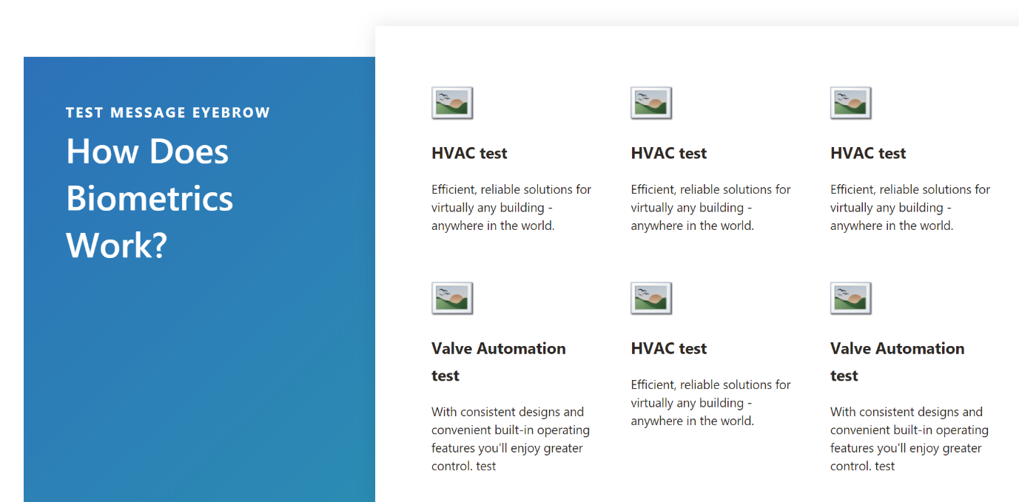

## Home Image Grid

|  |  |
| --- | --- |
| **Rendering** | /sitecore/layout/Renderings/Feature/Components/Home Image Grid |
| **Data Source** | * /sitecore/templates/Feature/Components/Home Image Grid/Home Image Grid * /sitecore/templates/Feature/Components/Home Image Grid/Home Image Grid Card |

Ability for content author to add a home image grid to a page. The home image grid will then allow you to add multiple sublayouts. The sublayouts are 4x4x4, 4x8, 6x6, 8x4.  Each sublayout has a placeholder as well.  To each placeholder, the author can enter either a Full Card or Partial Card.  A Full Card shows the entire image. A Partial Card shows the image with white for the background underneath

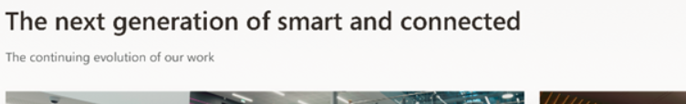

Next, for each image tile you want to display in the image grid, create a new item from the **Home Image Grid Card** template.

Each of these items controls the **Title**, **Description** and **Image** of one of the grid tiles.

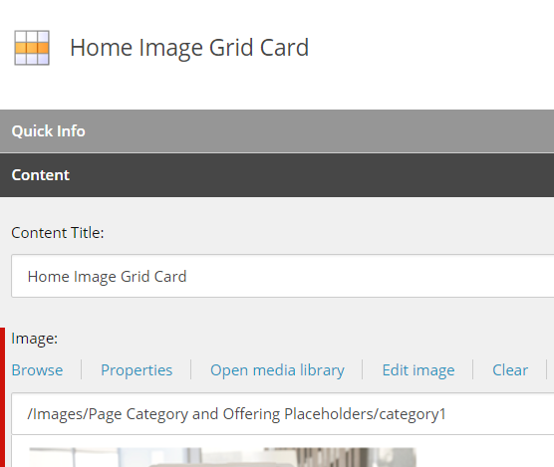

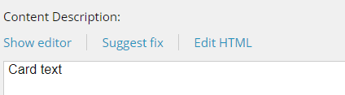

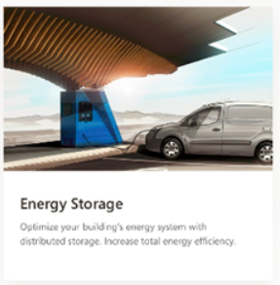

**Associate the content**

Using either the experience editor or the presentation details menu, add a **Universal Home Image Grid** rendering to a page and then associate its datasource to the first item you created earlier.

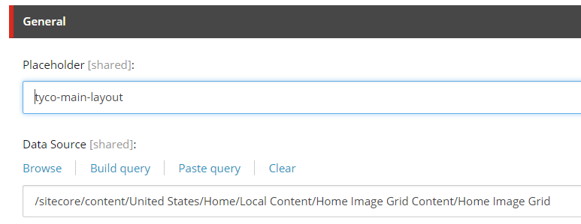

This will expose a new placeholder, where you can add any of the **four** **row renderings (listed below)** that control the display options for the cards. These row renderings do not take a datasource themselves, but simply expose more placeholders where the cards will be added.

* 8x4 Row (Wide left, narrow right card)
* 4x8 Row (Narrow left, wide right card)
* 6x6 Row (Two equally sized cards)
* 4x4x4 Row (Three equally sized cards)

This example uses an 8x4 row and then a 4x8 row:

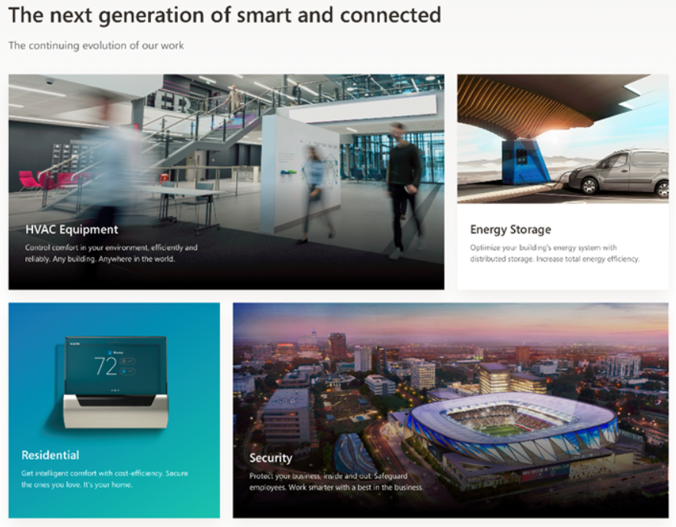

Finally, click into the placeholders inside the row and add one of the two card renderings: **Full Card** or **Partial Card**. Each of these cards will use the same card datasource type; the difference is whether the image extends to the bottom of the card or only to the beginning of the text.

Partial Card:

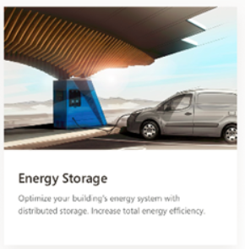

Full Card:

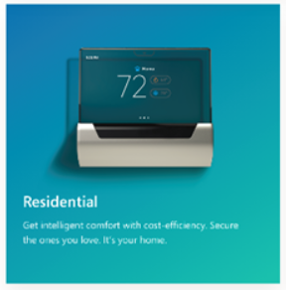

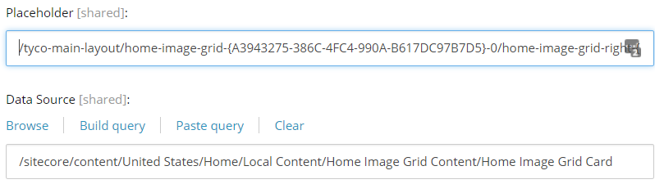

## Home Inpage Banner Rendering

|  |  |
| --- | --- |
| **Rendering** | /sitecore/layout/Renderings/Feature/Components/Home Inpage Banner |
| **Data Source** | /sitecore/templates/Feature/Components/Image Text/Image Text Content |

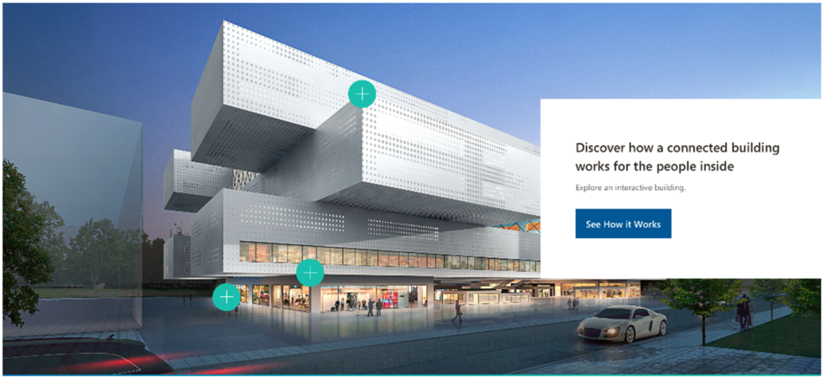

## Home Two Column Flare Rendering

|  |  |
| --- | --- |
| **Rendering** | /sitecore/layout/Renderings/Feature/Components/Home Two Column Flare/Universal Home Two Column Flare  /sitecore/layout/Renderings/Feature/Components/Home Two Column Flare/Universal Home Two Column Flare Card |
| **Data Source** | /sitecore/templates/Feature/Components/Image Text/Image Text Content |

### Data Source

Create two new items from the **Image Text Content** template.

The datasource controls the **Title**, **Text**, **Link, Link Text,** and **Image** for one of the flares in the rendering. There are two datasources, one for each side.

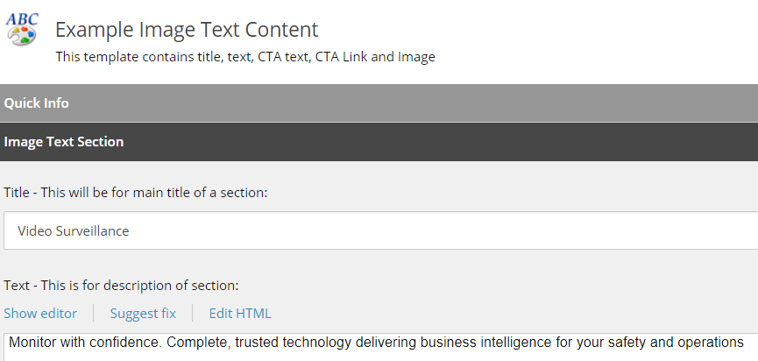 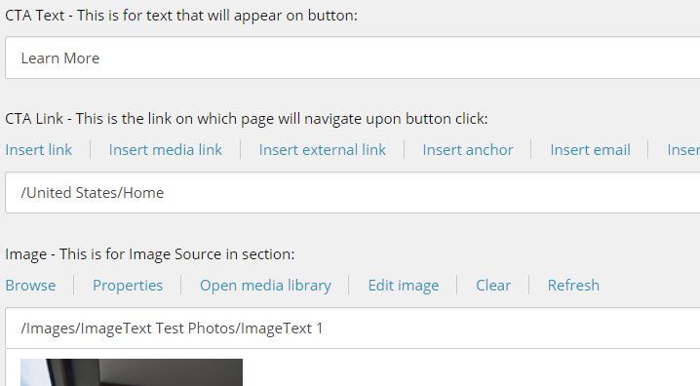

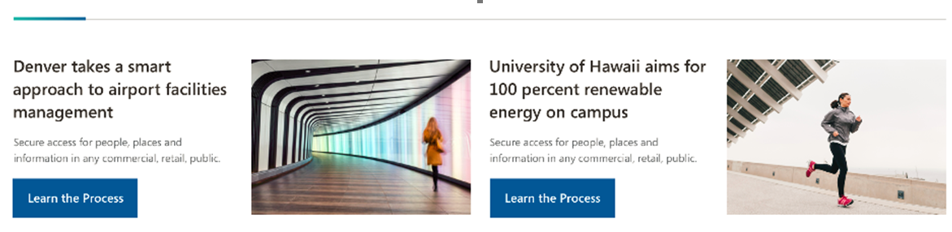

### Associate the content

Using either the experience editor or the presentation details menu, add a **Home Two Column Flare** rendering to a page. This will expose two placeholders, where you can then add a **Home Two Column Flare Care** rendering and then associate its datasource to one of the items you created earlier. Repeat for the second placeholder and datasource.

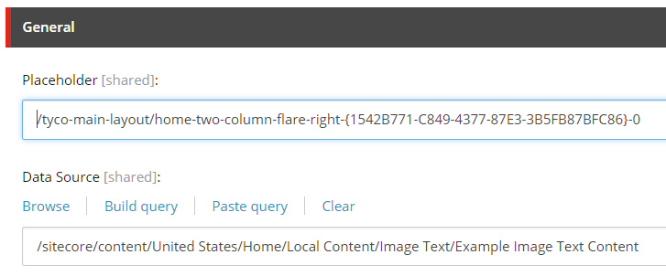

## Icon List

|  |  |
| --- | --- |
| **Rendering** | /sitecore/layout/Renderings/Feature/Components/Icon List |
| **Data Source** | /sitecore/templates/Feature/Components/Icon List/Icon List  /sitecore/templates/Feature/Components/Icon List/Icon List Item |

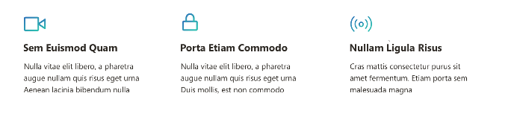

The Icon list itself does not contain any fields. Instead, it contains children for each icon. The data source for each icon includes:

* Icon – image reference for the icon
* Link
* Link Text
* Description

## Image Gallery

|  |  |
| --- | --- |
| **Rendering** | /sitecore/layout/Renderings/Feature/Components/Image Gallery |
| **Data Source** | /sitecore/templates/Feature/Components/Image Gallery/Image Gallery Item  /sitecore/templates/Feature/Components/Image Gallery/Image  /sitecore/templates/Feature/Components/Image Gallery/Video  /sitecore/templates/Feature/Components/Image Gallery/Video Type Selection List Item |

Allows you to create a tile slide image or video. Each gallery item can have a caption. Video types should be YouTube, Vimeo, MP4.

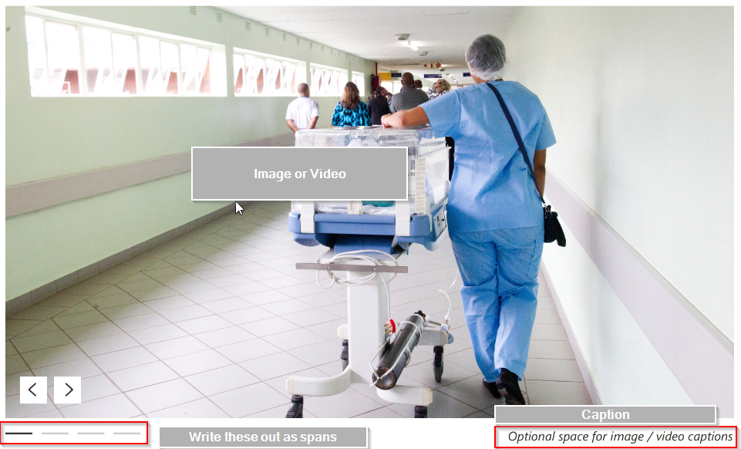

## Image with content

|  |  |
| --- | --- |
| **Rendering** | /sitecore/layout/Renderings/Feature/Components/Image Text |
| **Data Source** | /sitecore/templates/Feature/Components/Image Text/Image Text Content |

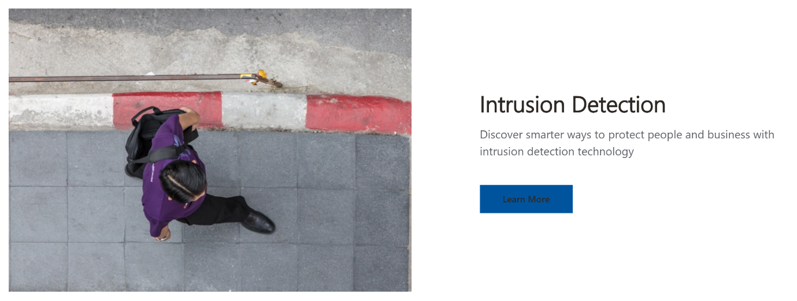

Variants include:

* Image Left Content Right
* Image Left Content Right Variant 2
* Image Left Content Right Wide
* Image Right Content Left
* Image Right Content Left Variant 2
* Image Right Content Left Wide

Info Panel (And Sublayouts)

|  |  |
| --- | --- |
| **Rendering** | /sitecore/layout/Renderings/Feature/Components/Info Panel/Universal Info Panel  /sitecore/layout/Renderings/Feature/Components/Info Panel/Universal Info Panel Sublayout 4x4x4  /sitecore/layout/Renderings/Feature/Components/Info Panel/Universal Info Panel Sublayout 6x6 |

### Using the rendering

The info panel itself takes no datasource and exposes placeholders for additional content.

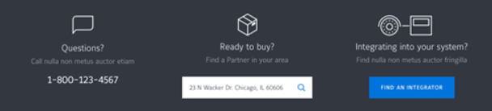

There are options for two columns (Sublayout 6x6) and three columns (Sublayout 6x6x6).

Regardless of the number of columns, you can insert a Text Card, a CTA Card, or Location Finder Card into any of the columns.

Info Panel Text Card

|  |  |
| --- | --- |
| **Rendering** | /sitecore/layout/Renderings/Feature/Components/Info Panel/Universal Info Panel Text Card |
| **Data Sources** | /sitecore/templates/Feature/Components/Info Panel/Text Card |

### Create the Datasource

Create a new item from the **Universal Info Panel Text Card** template. This controls the text and icon.

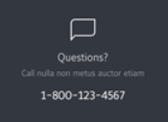

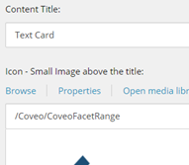

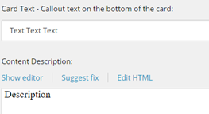

### Associate the content

Using either the experience editor or the presentation details menu, add a **Text Card** rendering to a page and then associate its datasource to the item you created earlier.

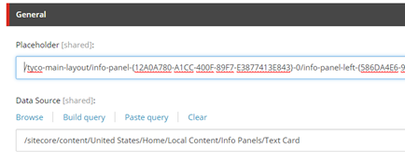

Info Panel CTA Card

|  |  |
| --- | --- |
| **Rendering** | /sitecore/layout/Renderings/Feature/Components/Info Panel/Universal Info Panel CTA Card |
| **Data Sources** | /sitecore/templates/Feature/Components/Info Panel/CTA Card |

### Create the Datasource

Create a new item from the **Universal Info Panel CTA Card** template. This controls the text, link and icon.

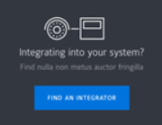

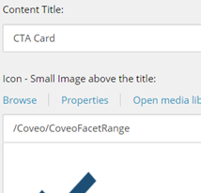

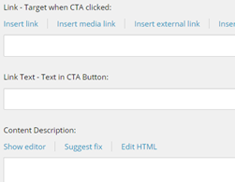

### Associate the content

Using either the experience editor or the presentation details menu, add a **CTA Card** rendering to a page and then associate its datasource to the item you created earlier.

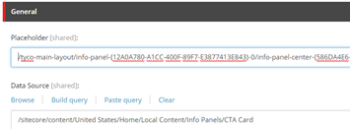

## Jumbo Header

|  |  |
| --- | --- |
| **Rendering** | /sitecore/layout/Renderings/Feature/Components/Jumbo Header |
| **Data Source** | /sitecore/templates/Feature/Components/Jumbo Header Data/Jumbo Header Data |

Component that can serve as a header in any page.



## Key Action

|  |  |
| --- | --- |
| **Rendering** | /sitecore/layout/Renderings/Feature/Components/Key Actions |
| **Data Source** | /sitecore/templates/Feature/Components/Key Actions/Key Actions |

Key Action Big Callout allows the user to add a single line text title, a link, text for the link, a cta box with text and link, and a background image. The image can be aligned to the left or the right. If the user clicks on "download", a download icon should appear in the output

Variants Include:

* Key Action Small Callout
* Key Actions

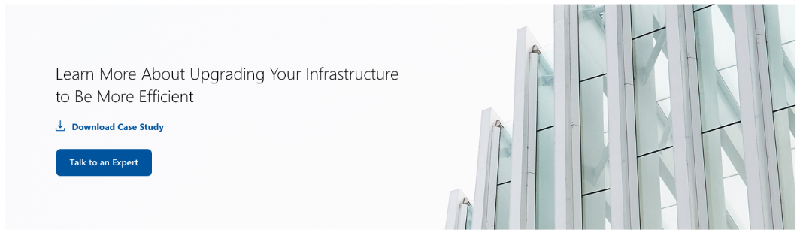

## Related Offerings Card

|  |  |
| --- | --- |
| **Rendering** | /sitecore/layout/Renderings/Feature/Components/Related Offerings/Related Offering Card |
| **Data Sources** | /sitecore/templates/Feature/Components/Related Offerings/Related Offering Card |

### Create the Datasource

Create a new item from the **Related Offering Card** template. This controls the text and hover color.

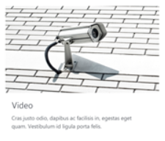

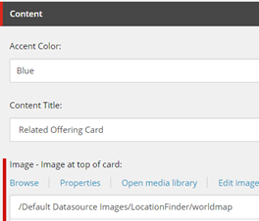

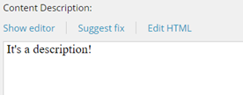

### Associate the content

Using either the experience editor or the presentation details menu, add a **Related Offering Card** rendering to a page and then associate its datasource to the item you created earlier.

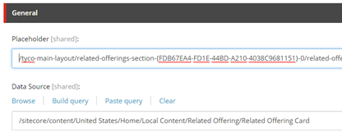

## Related Offerings Section (And Sublayout)

|  |  |
| --- | --- |
| **Rendering** | /sitecore/layout/Renderings/Feature/Components/Related Offerings/Related Offering Section  /sitecore/layout/Renderings/Feature/Components/Related Offerings/Related Offering Sublayout 4x4x4 |
| **Data Sources** | /sitecore/templates/Feature/Components/Related Offerings/Related Offering Section |

### Create the Datasource

Create a new item from the **Related Offering Section** template. This controls the title above the cards.

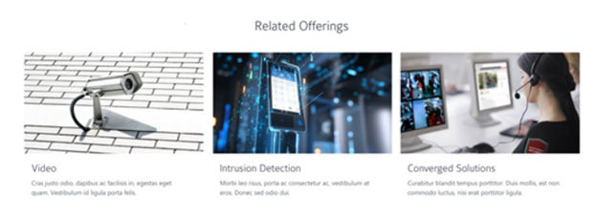

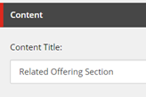

The rendering exposes a placeholder for a three column sublayout (**Sublayout 4x4x4**). Each column’s placeholder accepts a Related Offering Card rendering.

### Associate the content

Using either the experience editor or the presentation details menu, add a **Related Offering Section** rendering to a page and then associate its datasource to the item you created earlier.

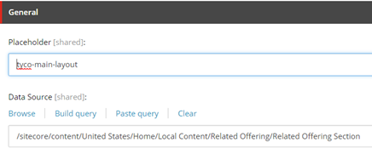

## Small Header

|  |  |
| --- | --- |
| **Rendering** | /sitecore/layout/Renderings/Feature/Components/Small Header/Small Header |
| **Data Source** | /sitecore/templates/Feature/Components/Small Header/Small Header |

### Create the Datasource

Create a new item from the **Small Header** template. It controls the text on the small header



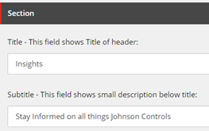

### Associate the content

Using either the experience editor or the presentation details menu, add a **Small Header** rendering to a page and then associate its datasource to the item you created earlier.

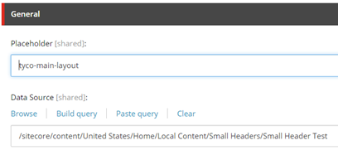

## Solution Card

|  |  |
| --- | --- |
| **Rendering** | /sitecore/layout/Renderings/Feature/Components/Solution Card List/Universal Solution Card |
| **Data Source** | /sitecore/templates/Feature/Components/Solution Card List/Solution Card |

### Create the Datasource

Create a new item from the **Solution Card** data source item. It can be added to the solution-card-list placeholder on the Universal Solution Card List rendering. The card displays an image, link, text description, and content from a related Insight item.

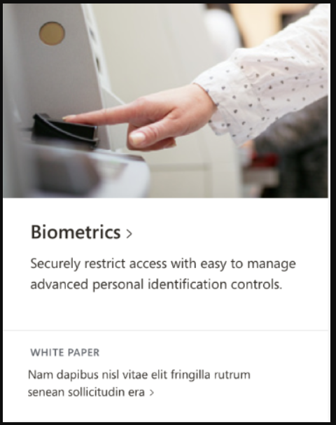

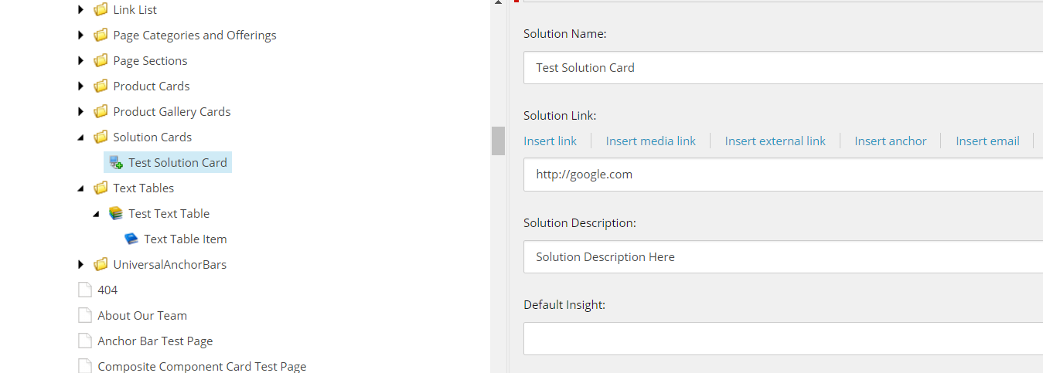

### Associate the content

Using either the experience editor or the presentation details menu, add a **Solution Card** rendering to a page and then associate its datasource to the item you created earlier.

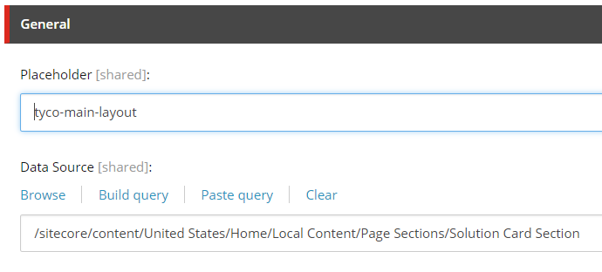

## Solution Card List Update

Rendering: /sitecore/layout/Renderings/Feature/Components/Solution Card List/Universal Solution Card List

### Using the rendering

The **Universal Solution Card List** rendering can be added inside of the Page Section rendering, on the page-section placeholder. The solution card list itself has no content or datasource but exposes the **solution-card-list** placeholder to add Solution Cards.

## Tab Control and Tab Panel

|  |  |
| --- | --- |
| **Rendering** | /sitecore/layout/Renderings/Feature/Components/Tab Control/Tab Control  /sitecore/layout/Renderings/Feature/Components/Tab Control/Tab Panel |
| **Data Source** | /sitecore/templates/Feature/Components/Tab Control/Tab Control  /sitecore/templates/Feature/Components/Tab Control/Tab Panel |

### Create the Datasource

Create a new item from the **Tab Control** template.

For each tab you want the control to display, add a child **Tab Panel item**. The title field of the panel item will be displayed in the name of the tab.

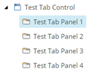 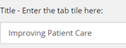

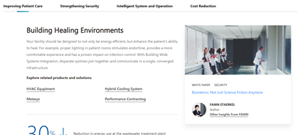

### Associate the content

Using either the experience editor or the presentation details menu, add a **Tab Control** rendering to a page and then associate its datasource to the parent item you created earlier.

Each tab panel exposes a placeholder where you can add a variety of renderings using experience editor.

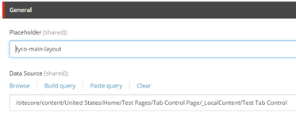

## Technical Support Panel

|  |  |
| --- | --- |
| **Rendering** | /sitecore/layout/Renderings/Feature/Components/Technical Support Panel/Technical Support Panel |
| **Data Source** | /sitecore/templates/Feature/Components/Technical Support Panel Data/Technical Support Panel Data  /sitecore/templates/Feature/Components/Technical Support Panel Item Data/Technical Support Panel Item Data |

### Create the Datasource

Create a new item from the **Technical Support Panel Data** template.

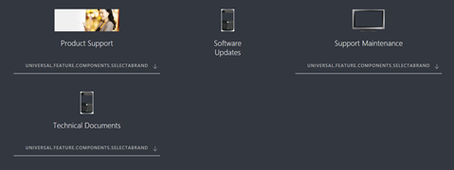

For each tile you want to display, add a child Technical Support Panel Item Data item. This controls the text, image and link list.

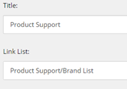

The links in the expanded view are defined by the link list field. You can add a Link List as a child and then set the Link List field to point to that child.

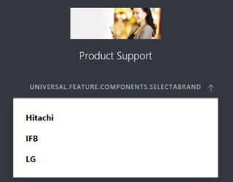

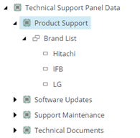

Additional text customization is available through dictionary entries at **/sitecore/content/Global Content/Dictionary/Feature/Components**

### Associate the content

Using either the experience editor or the presentation details menu, add a **Technical Support Panel** rendering to a page and then associate its datasource to the item you created earlier.

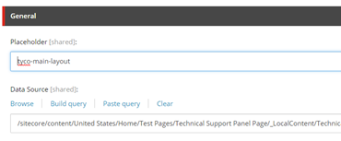

## Text List Rollup

|  |  |
| --- | --- |
| **Rendering** | /sitecore/templates/Feature/Components/Text List Rollup/Text List |
| **Data Source** | /sitecore/templates/Feature/Components/Text List Rollup/Text List  /sitecore/templates/Feature/Components/Text List Rollup/Text List Item |

### Create the Datasource

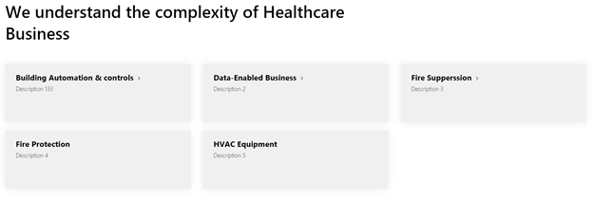

Create a new item from the **Text List Rollup** template. This datasource item controls the text, background color and layout of the child items.

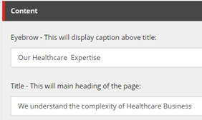

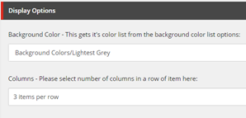

Add a child **Text List Item** for each link you want to display. This controls the text and link of an individual tile.

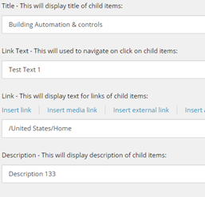

### Associate the content

Using either the experience editor or the presentation details menu, add a **Text List Rollup** rendering to a page and then associate its datasource to the item you created earlier.

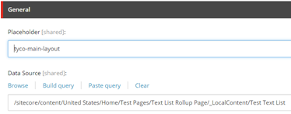

## Text Table

|  |  |
| --- | --- |
| **Rendering** | /sitecore/layout/Renderings/Feature/Components/Text Table/Universal Text Table |
| **Data Source** | /sitecore/templates/Feature/Components/Text Table/Text Table  /sitecore/templates/Feature/Components/Text Table/Text Table Item |

### Create the Datasource

The **Universal Text Table** displays a title and three columns of rich text.

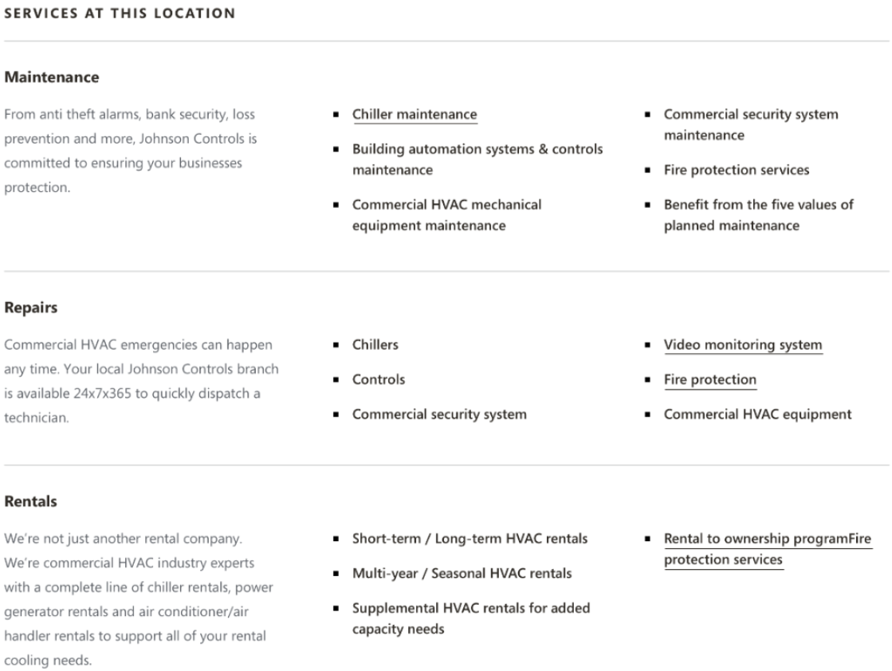

The entire table is controlled by a **Text Table** datasource. Each row, with its title and three columns, are controlled by children of the datasource: **Text Table Items**.

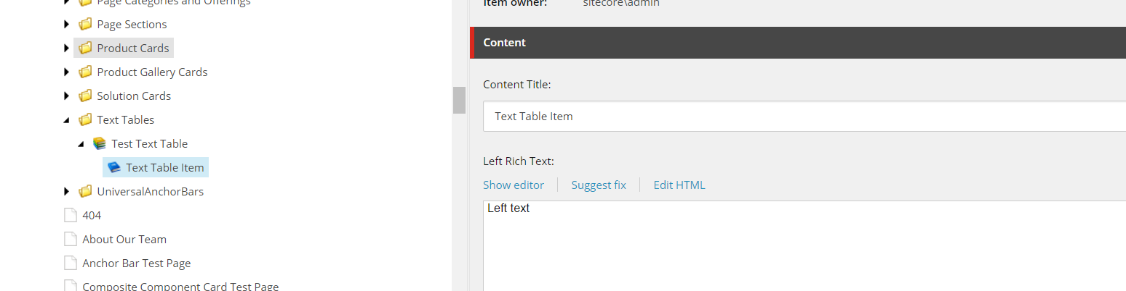

### Associate the content

Using either the experience editor or the presentation details menu, add a **Text Table** rendering to a page and then associate its datasource to the item you created earlier.

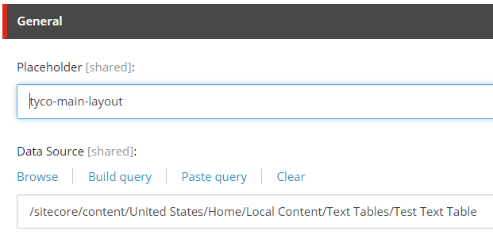

## Video Anchor Button

Datasource Template: /sitecore/templates/Feature/Components/Video Anchor Button/Video Anchor Button

Rendering: /sitecore/layout/Renderings/Feature/Components/Video Anchor Button/Video Anchor Button

### Create the Datasource

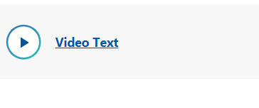

Create a new item from the **Video Anchor Button** template.

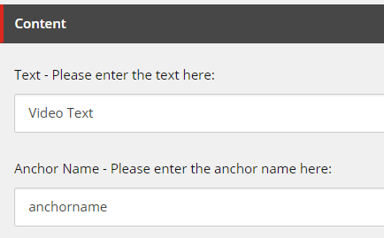

The datasource controls the button text and the anchor name. The anchor name is not displayed but is used to link the button to a Video Display rendering elsewhere on the page. When clicked, if a matching Video Display rendering is present, the page will focus on the video rendering.

### Associate the content

Using either the experience editor or the presentation details menu, add a **Video Anchor Button** rendering to a page and then associate its datasource to the item you created earlier.

## Video Display

Datasource Template: /sitecore/templates/Feature/Components/Video Display/Video Display

Rendering: /sitecore/layout/Renderings/Feature/Components/Video Display/Video Display

### Create the Datasource

Create a new item from the **Video Display** template.

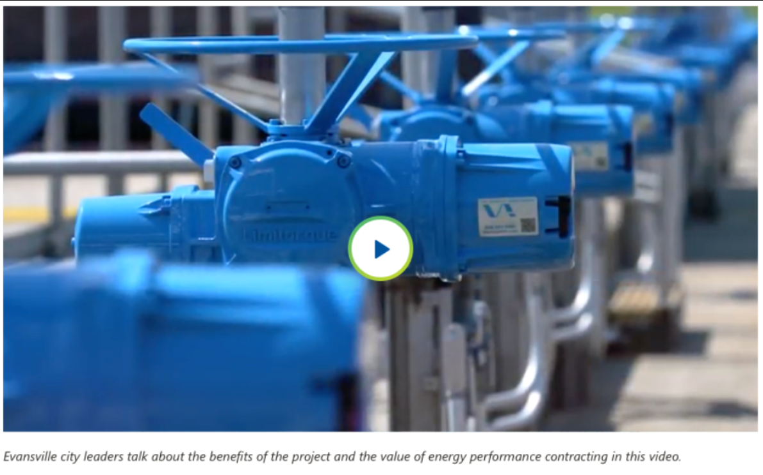

The datasource controls the video itself along with the caption. The Anchor name field is used to match the control with a Video Anchor Button. When a matching Video Anchor Button is clicked, the page will focus on the video rendering.

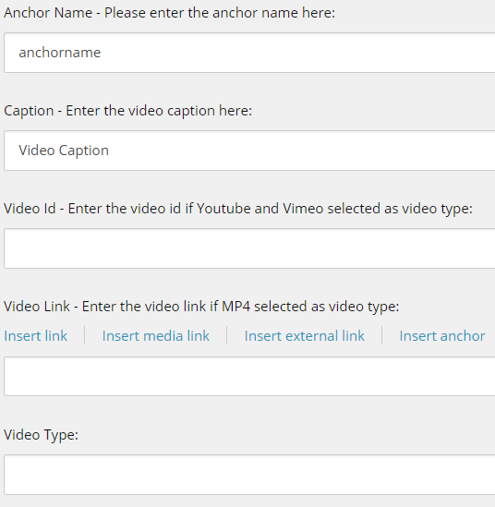

### Associate the content

Using either the experience editor or the presentation details menu, add a **Video Display** rendering to a page and then associate its datasource to the item you created earlier.

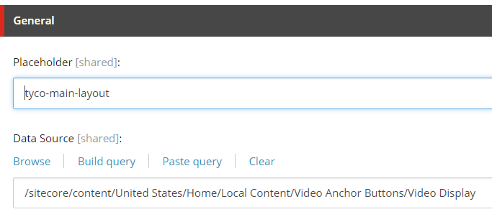

# Events Feature

## Download

|  |  |
| --- | --- |
| **Rendering** | /sitecore/layout/Renderings/Feature/Events/Download/Download |
| **Data Source** | /sitecore/templates/Feature/Events/Download/Download  /sitecore/templates/Feature/Events/Download/Download Item |

### Create the Datasource

The Download rendering displays a list of files with download links. Create a new item from the **Download** template.

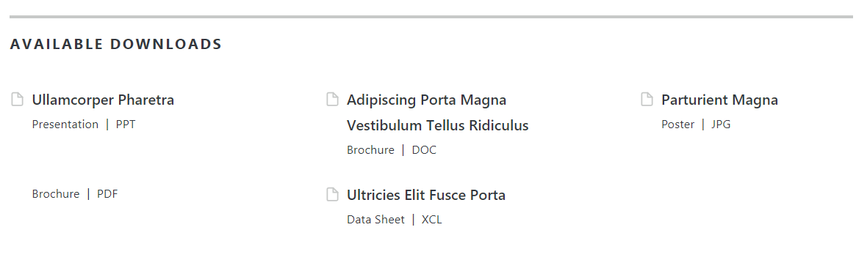

The download item controls the text title of the rendering.

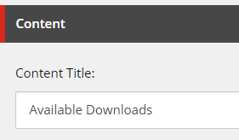

For each individual link to display, add a Download Item as a child to the Download datasource you created.

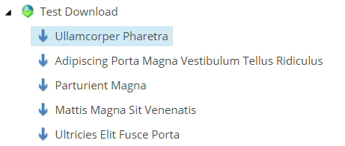

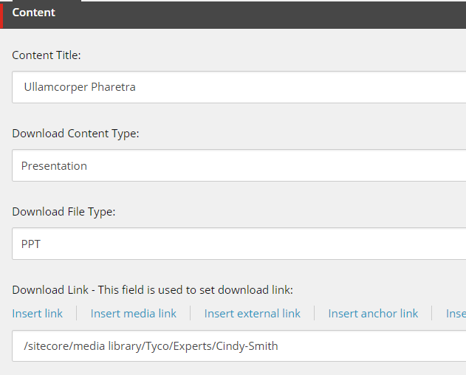

Each Download item controls the text and link of one file for download.

### Associate the content

Using either the experience editor or the presentation details menu, add a **Download** rendering to a page and then associate its datasource to the Download parent item item you created earlier.

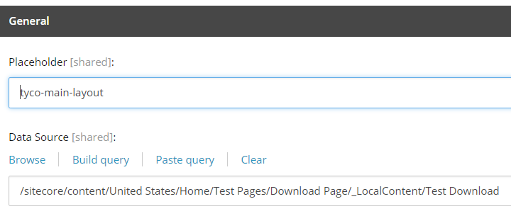

## Event By Line

|  |  |
| --- | --- |
| **Rendering** | /sitecore/layout/Renderings/Feature/Events/Event By Line/Event By Line |
| **Page Template** | /sitecore/templates/Feature/Events/Event Detail/_Event Detail |

### Update the Page Data

The Event By Line rendering does not take a datasource, but renders fields from the page it is placed on. It expects to be placed on an Event Detail page and renders the Event’s tags and share links.



Additional text customization is available through dictionary entries at **/sitecore/content/Global Content/Dictionary/Feature/Events**

### Associate the content

Using either the experience editor or the presentation details menu, add an **Event By Line** rendering to a page that inherits from the _Event Detail template. No datasource is required.

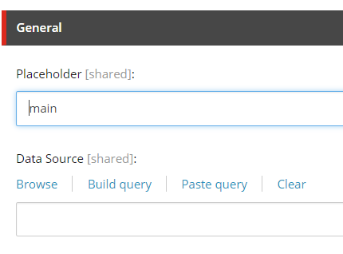

## Event Detail

|  |  |
| --- | --- |
| **Rendering** | /sitecore/layout/Renderings/Feature/Events/Event By Line/Event Detail |
| **Page Template** | /sitecore/templates/Feature/Events/Event Detail/_Event Detail |

### Update the Page Data

The Event Detail rendering does not take a datasource, but renders fields from the page it is placed on. It expects to be placed on an Event Detail page and renders the Event’s date text, location and Long Description, along with a placeholder for an optional registration form.

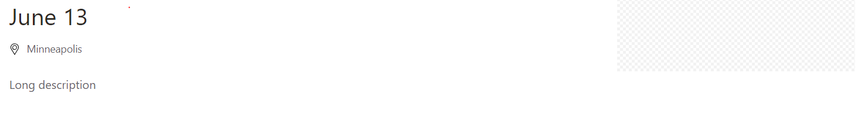

Additional text customization is available through dictionary entries at **/sitecore/content/Global Content/Dictionary/Feature/Events**

### Associate the content

Using either the experience editor or the presentation details menu, add an **Event Detail** rendering to a page that inherits from the _Event Detail template. No datasource is required.



## Event Header

|  |  |
| --- | --- |
| **Rendering** | /sitecore/layout/Renderings/Feature/Events/Event Header/Event Header |
| **Page Template** | /sitecore/templates/Feature/Events/Event Detail/_Event Detail |

### Create or Locate the Page Data

The Event Header rendering does not take a datasource itself but uses fields from the page it is placed on. Specifically, it renders the Event Title.



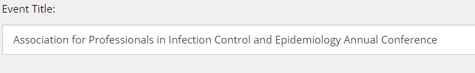

Additional text customization is available through dictionary entries at **/sitecore/content/Global Content/Dictionary/Feature/Events**

### Associate the content

Using either the experience editor or the presentation details menu, add an **Event Header** rendering to a page.

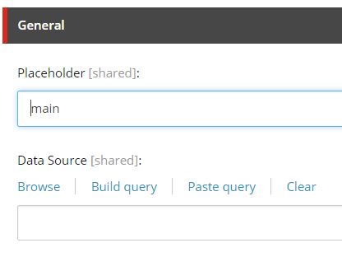

## Featured Event (or Webinar)

|  |  |
| --- | --- |
| **Rendering** | /sitecore/layout/Renderings/Feature/Events/Featured Event/Featured Event |
| **Page Template** | /sitecore/templates/Feature/Events/Event Detail/_Event Detail  OR  /sitecore/templates/Feature/Events/Webinar Detail/_Webinar Detail |

### Create the Datasource

The Featured Event rendering displays fields from an **Event** or **Webinar** page.

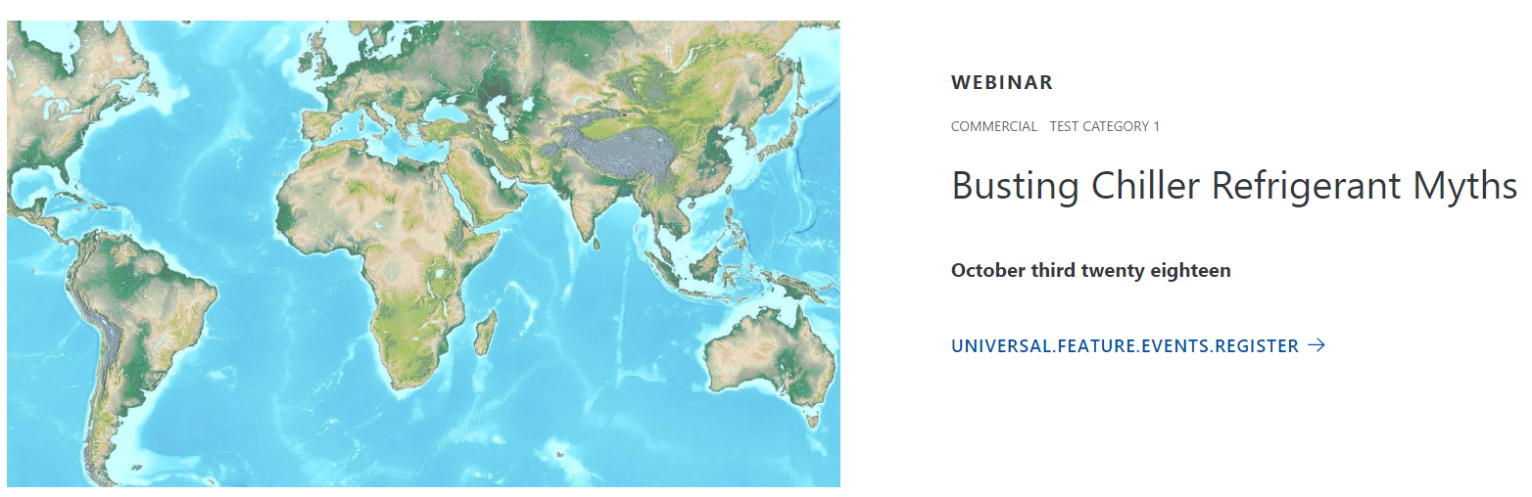

The rendering displays the content type (event or webinar), tags, Title, Date Text, and Image along with a link to the page.

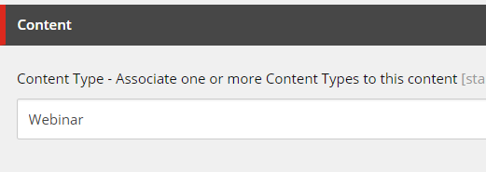

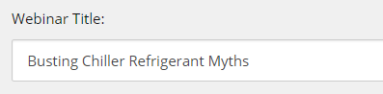

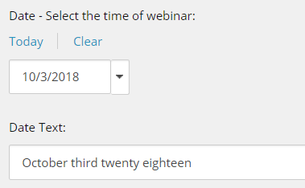

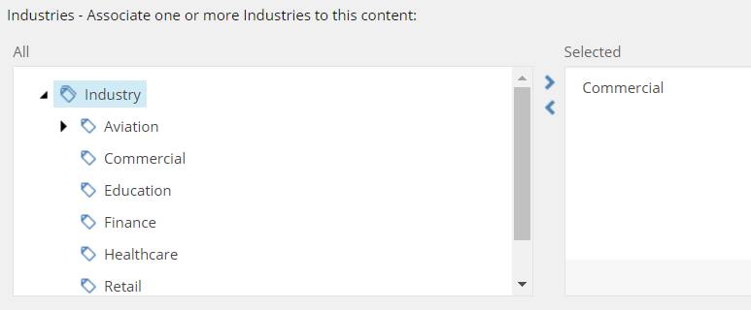

Additional text customization is available through dictionary entries at **/sitecore/content/Global Content/Dictionary/Feature/Events**

### Associate the content

Using either the experience editor or the presentation details menu, add a **Featured Event** rendering to a page and then associate its datasource to the page you edited earlier.

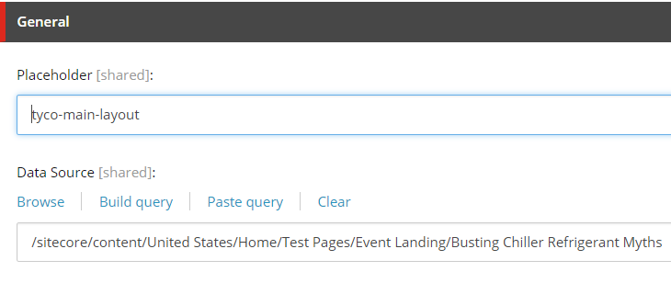

## Hosted By

|  |  |
| --- | --- |
| **Rendering** | /sitecore/layout/Renderings/Feature/Events/Hosted By/Hosted By |
| **Page Template** | /sitecore/templates/Feature/Events/Webinar Detail/_Webinar Detail |

### Create or Locate the Page Data

The Hosted By rendering does not take a datasource itself but uses fields from the page it is placed on. Specifically, it renders the Hosted By field’s selected author’s data.



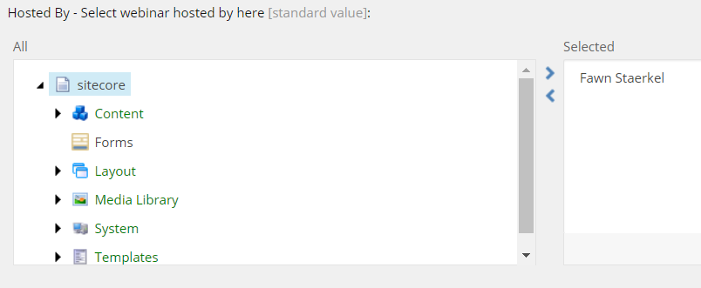

From the selected author, the rendering uses First Name, Last Name and Image.

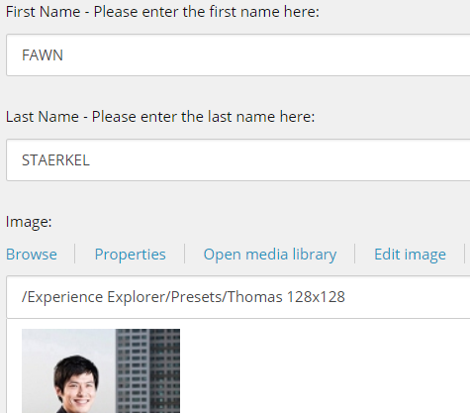

Additional text customization is available through dictionary entries at **/sitecore/content/Global Content/Dictionary/Feature/Events**

### Associate the content

Using either the experience editor or the presentation details menu, add a **Hosted By** rendering to the webinar page you edited earlier.

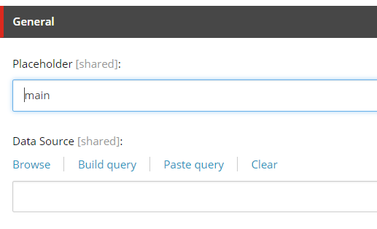

## Upcoming Events

|  |  |
| --- | --- |
| **Rendering** | /sitecore/layout/Renderings/Feature/Events/Upcoming Event/Upcoming Events |
| **Data Source** | None (Content loaded dynamically) |

### Use the rendering

Using either the experience editor or the presentation details menu, add an **Upcoming Events** rendering to a page.

The rendering will dynamically find the three events or webinars that are the soonest and will display their details with a link to their pages.

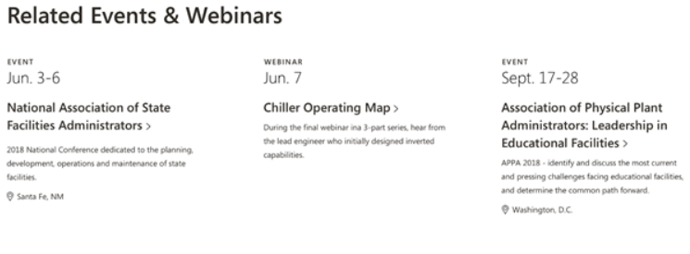

Additional text customization is available through dictionary entries at **/sitecore/content/Global Content/Dictionary/Feature/Events**

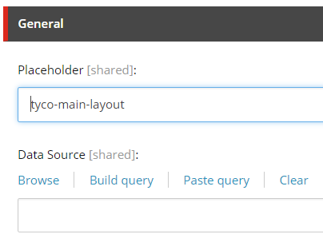

## Webinar Detail

|  |  |
| --- | --- |
| **Rendering** | /sitecore/layout/Renderings/Feature/Events/Event By Line/Webinar Detail |
| **Page Template** | /sitecore/templates/Feature/Events/Event Detail/_Webinar Detail |

### Update the Page Data

The Webinar Detail rendering does not take a datasource but renders fields from the page it is placed on. It expects to be placed on an Webinar Detail page and renders the Webinar’s duration, date text, location and Long Description, along with a placeholder for an optional registration form.



Additional text customization is available through dictionary entries at **/sitecore/content/Global Content/Dictionary/Feature/Events**

### Associate the content

Using either the experience editor or the presentation details menu, add an **Webinar Detail** rendering to a page that inherits from the _Webinar Detail template. No datasource is required.

## Webinar Header

|  |  |
| --- | --- |
| **Rendering** | /sitecore/layout/Renderings/Feature/Events/Event Header/Webinar Header |
| **Page Template** | /sitecore/templates/Feature/Events/Event Detail/_Webinar Detail |

### Create or Locate the Page Data

The Webinar Header rendering does not take a datasource itself but uses fields from the page it is placed on. Specifically, it renders the Webinar Title.



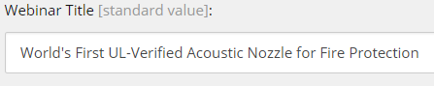

Additional text customization is available through dictionary entries at **/sitecore/content/Global Content/Dictionary/Feature/Events**

### Associate the content

Using either the experience editor or the presentation details menu, add an **Webinar Header** rendering to a page.





## Landing Header

|  |  |
| --- | --- |
| **Rendering** | /sitecore/layout/Renderings/Feature/Components/Landing Header/Landing Header |
| **Page Template** | /sitecore/templates/Feature/Components/Landing Header/Landing Header |

### Create or Locate the Landing Header data

The Landing Header rendering takes a datasource.



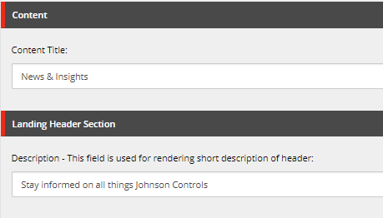

### Associate the content

Using either the experience editor or the presentation details menu, add a **Landing Header** rendering to a page.

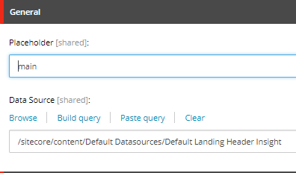

# Insights Feature

## Featured Insight

|  |  |
| --- | --- |
| **Rendering** | /sitecore/layout/Renderings/Feature/Insights/Featured Insight/Featured Insight |
| **Page Template** | /sitecore/templates/Feature/Insights/Insight Article/_Insight Article |

### Locate or Create the Datasource

The featured insight uses an Insight Article page as a datasource. Find or create the Insight Article page you want to feature.

The fields used by the Featured Insight rendering include the page image, tags, Insight Title and Author.

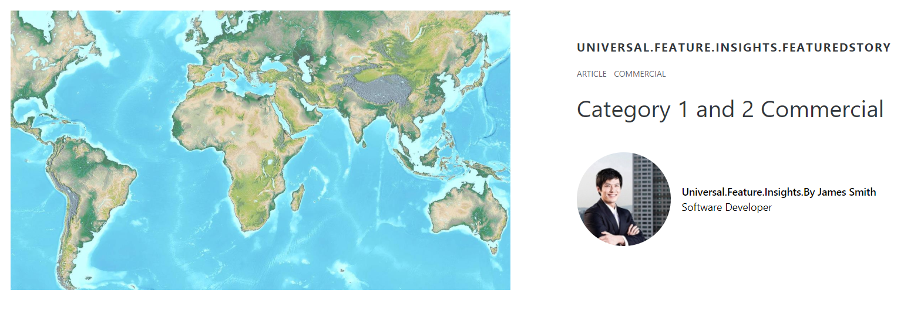

Additional text customization is available through dictionary entries at **/sitecore/content/Global Content/Dictionary/Feature/Insights**

### Associate the content

Using either the experience editor or the presentation details menu, add a **Featured Insight** rendering to a page and then associate its datasource to the page you created or located earlier.

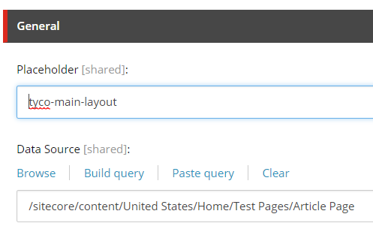

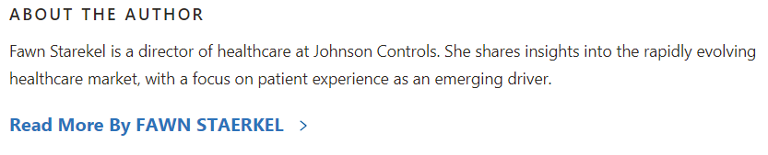

## Insight About the Author

|  |  |
| --- | --- |
| **Rendering** | /sitecore/layout/Renderings/Feature/Insights/Insight About the Author/Insight About the Author |
| **Page Template and Associated Data Template** | Page Template: /sitecore/templates/Feature/Insights/Insight Article/_Insight Article  Author Template: /sitecore/templates/Foundation/Common/Author/Author |

### Create or Locate the Page Data

The About the Author rendering does not take a datasource itself but uses fields from the page it is placed on. Specifically, it uses the Article Page’s Author Field.

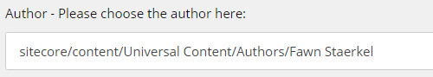

The author itself has several fields that are used by the rendering.

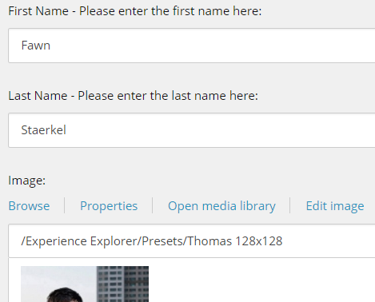

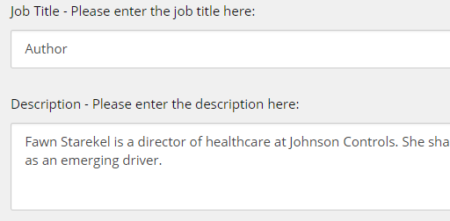

Additional text customization is available through dictionary entries at **/sitecore/content/Global Content/Dictionary/Feature/Insights**

### Associate the content

Usually the Article page template will include an **Insight About the Author** rendering by default. Ensure that your article page has an author selected, and that the author’s data is populated. Once you’ve done this you can add the rendering to your page using Presentation Details or the Experience Editor.

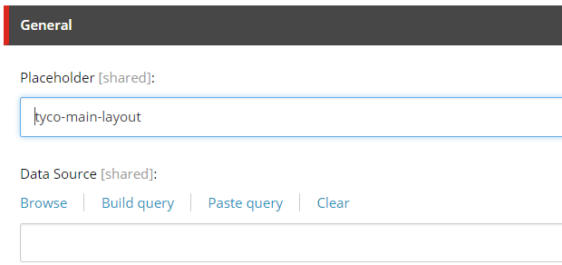

## Insight At A Glance

|  |  |
| --- | --- |
| **Rendering** | /sitecore/layout/Renderings/Feature/Insights/Insight At A Glance/Insight At A Glance |
| **Data Source** | /sitecore/templates/Feature/Insights/Insight At A Glance/Insight At A Glance |

### Create the Datasource

Create a new item from the **Insight at a Glance** template. The datasource controls the text of the rendering.

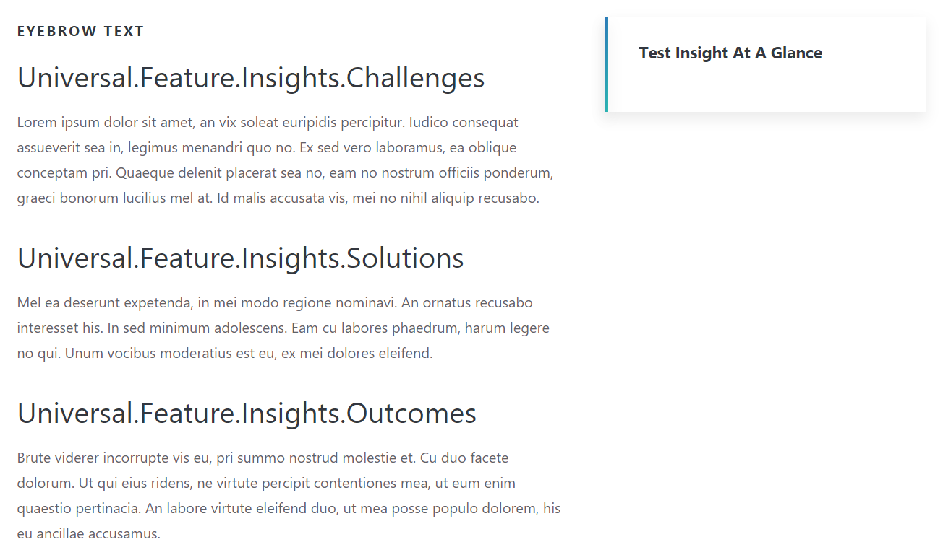

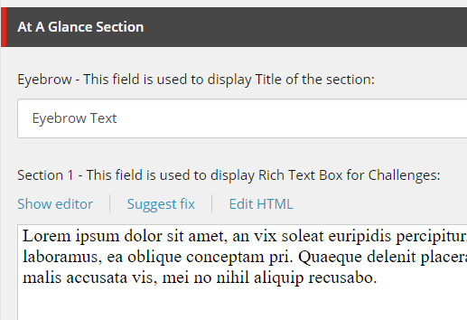

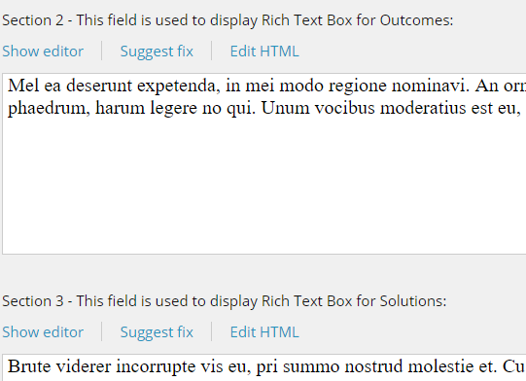

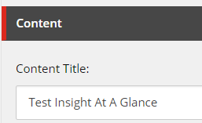

Additional text customization is available through dictionary entries at **/sitecore/content/Global Content/Dictionary/Feature/Insights**

### Associate the content

Using either the experience editor or the presentation details menu, add an **Insight at a Glance** rendering to a page and then associate its datasource to the item you created earlier.

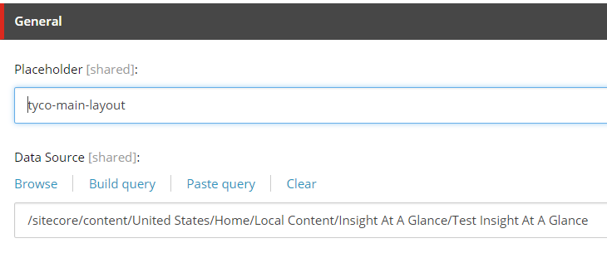

## Insight By Line

|  |  |
| --- | --- |
| **Rendering** | /sitecore/layout/Renderings/Feature/Insights/Insight By Line/Insight By Line |
| **Page Template** | /sitecore/templates/Feature/Insights/Insight Article/_Insight Article |

### Create the Datasource

The Insight By Line Rendering itself does not use a datasource, but takes data from the Article Page it’s placed on.



Article fields used by this rendering include start date, author and tags.

Additional text customization is available through dictionary entries at **/sitecore/content/Global Content/Dictionary/Feature/Insights**

### Associate the content

Using either the experience editor or the presentation details menu, add an **Insight By Line** rendering to the article page you edited earlier.

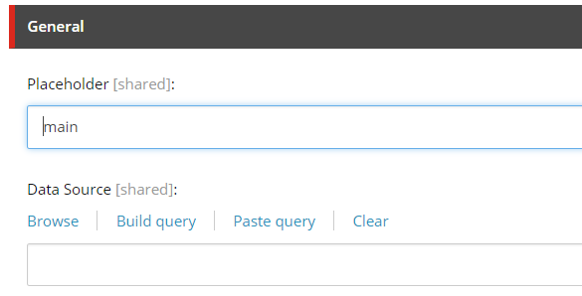

## Insight Data Callout 1 Column

|  |  |
| --- | --- |
| **Rendering** | /sitecore/layout/Renderings/Feature/Insights/Insight Data Callout 1 Column/Insight Data Callout 1 Column |
| **Data Source** | /sitecore/templates/Feature/Insights/Insight Data Callout 1 Column/Insight Data Callout 1 Column |

### Create the Datasource

Create a new item from the **Insight Data Callout 1 Column** template.

The datasource controls the text and borders of the rendering.



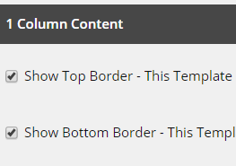

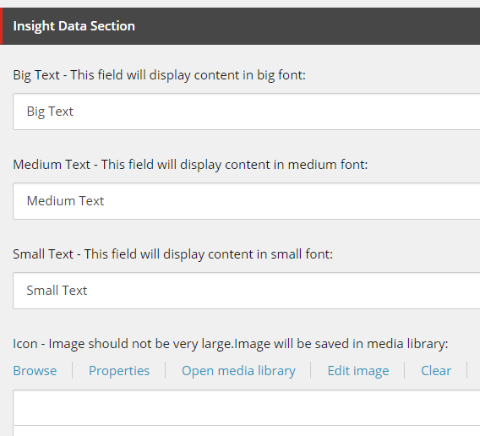

### Associate the content

Using either the experience editor or the presentation details menu, add an **Insight Data Callout 1 Column** rendering to a page and then associate its datasource to the item you created earlier.

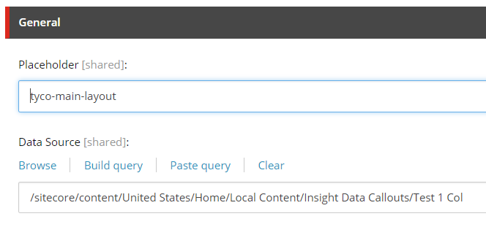

## Insight Data Callout 2 Column

Datasource Template: /sitecore/templates/Feature/Insights/Insight Data Callout 2 Column/Insight Data Callout 2 Column

Rendering: /sitecore/layout/Renderings/Feature/Insights/Insight Data Callout 2 Column/Insight Data Callout 2 Column

### Create the Datasource

Create a new item from the **Insight Data Callout 2 Column** template.

The datasource controls the top and bottom borders of the control.

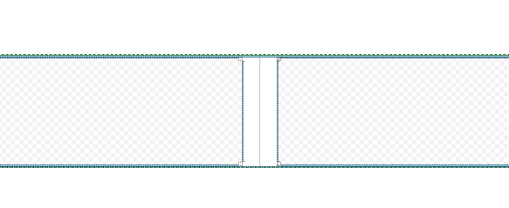

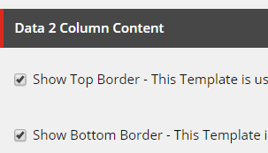

The rendering has two placeholders, **insight-data-left** and **insight-data-right**, where you can add an **Insight Data Small** rendering.

### Associate the content

Using either the experience editor or the presentation details menu, add an **Insight Data Callout 2 Column** rendering to a page and then associate its datasource to the item you created earlier.

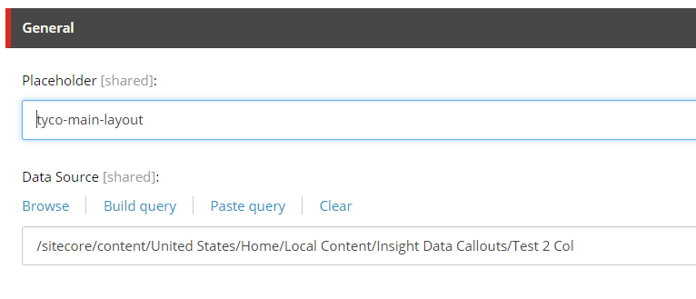

## Insight Data Callout Small

|  |  |
| --- | --- |
| **Rendering** | /sitecore/layout/Renderings/Feature/Insights/Insight Data Callout Small/Insight Data Small |
| **Data Source** | /sitecore/templates/Feature/Insights/Insight Data Small/Insight Data Small |

### Create the Datasource

Create a new item from the **Insight Data Small** template.

The datasource controls the text and image on the rendering.



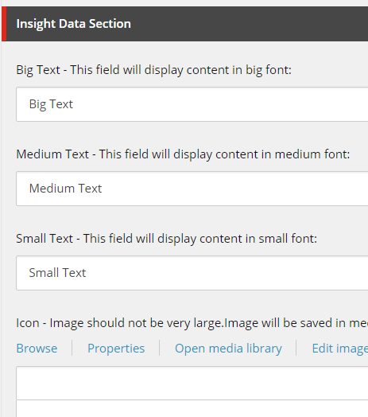

### Associate the content

Using either the experience editor or the presentation details menu, add an **Insight Data Small** rendering to a page and then associate its datasource to the item you created earlier.

By default, you can add an Insight Data Small Rendering to either side of an **Insight Data Two Column** rendering. (placeholders: **insight-data-left** and **insight-data-right**).

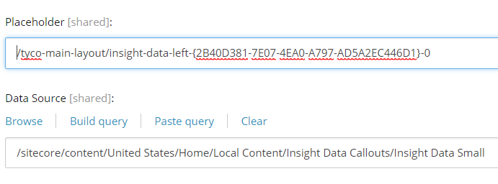

## Insight Header

|  |  |
| --- | --- |
| **Rendering** | /sitecore/layout/Renderings/Feature/Insights/Insight Header/Insight Header |
| **Page Template** | /sitecore/templates/Feature/Insights/Insight Article/_Insight Article |

### Create or Locate the Page Data

The Insight Header rendering does not take a datasource itself but uses fields from the page it is placed on. Specifically, it renders the Insight Title.



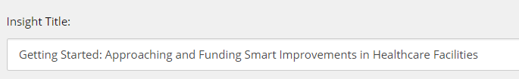

### Associate the content

Using either the experience editor or the presentation details menu, add an **Insight Header** rendering to a page.



## Insight Highlight

|  |  |
| --- | --- |
| **Rendering** | /sitecore/layout/Renderings/Feature/Insights/Insight Highlight/Insight Highlight |
| **Data Source** | /sitecore/templates/Feature/Insights/Insight Highlight/Insight Highlight |

### Create the Datasource

Create a new item from the **Insight Highlight** template. The data source controls the text in the callout.

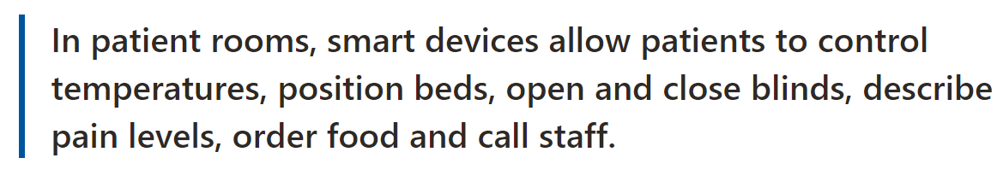

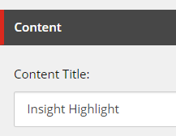

### Associate the content

Using either the experience editor or the presentation details menu, add an **Insight Highlight** rendering to a page and then associate its datasource to the item you created earlier.

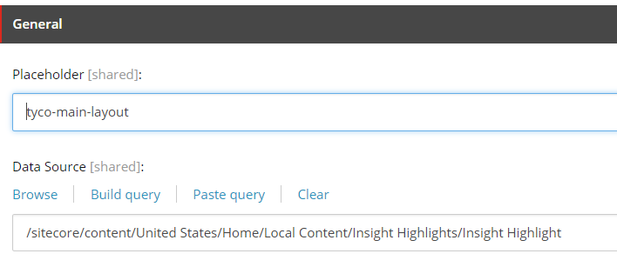

## Insight Panel Rendering

|  |  |
| --- | --- |
| **Rendering** | /sitecore/layout/Renderings/Feature/Insights/Insight Panel/Insight Panel |
| **Data Source** | /sitecore/templates/Feature/Insights/Insight Panel/Insight Panel |

### Create the Datasource

Create a new item from the **Insight Panel** template.

The datasource controls how many insights to display.

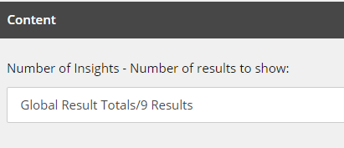

This rendering also uses the standard filter settings for displaying insights.

By default, insights will use the Insight Article and Webinar templates. There is a checkbox to include or exclude In The News items from results. These three templates are set on the Site Settings item.

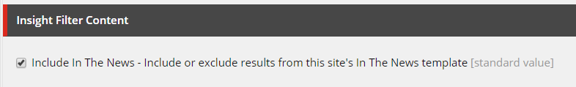

There are three fields to select tags for content (Channel, Category, and Industry) and a dropdown to choose the Logical Operator. Results must always match a selected channel tag. With logical operator set to OR, results will be returned if they match either a category or industry. If logical operator is set to AND the results must match both category and industry. In either case, if the search does not turn up enough results, a search will be done on only Category and Channel (ignoring industry) to try and add enough items to meet the required number.

### Associate the content

Using either the experience editor or the presentation details menu, add an **Insight Panel** rendering to a page and then associate its datasource to the item you created earlier.

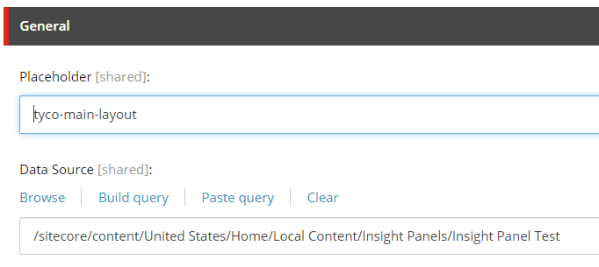

## Insight Quilt Dynamic and Insight Quilt Dynamic Slim Renderings

|  |  |
| --- | --- |
| **Rendering** | /sitecore/layout/Renderings/Feature/Insights/Insight Panel/Insight Panel |
| **Data Source** | /sitecore/templates/Feature/Insights/Insight Panel/Insight Panel |

### Create the Datasource

Create a new item from the **Insight Quilt Dynamic** template. Both the regular and slim renderings use the same datasource.

The datasource controls the text and display settings of the callout to the left of the quilt.

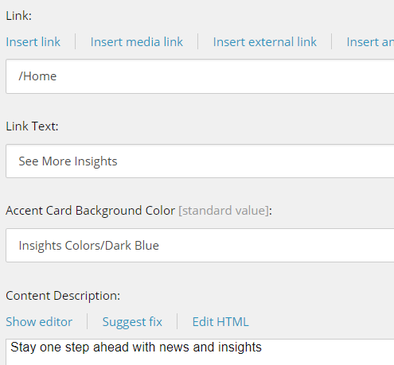 

For the insights to the right of the quilt, the slim variant will display one result while the regular variant will display two results.

This rendering also uses the standard filter settings for displaying insights.

By default, insights will use the Insight Article and Webinar templates. There is a checkbox to include or exclude In The News items from results. These three templates are set on the Site Settings item.



There are three fields to select tags for content (Channel, Category, and Industry) and a dropdown to choose the Logical Operator. Results must always match a selected channel tag. With logical operator set to OR, results will be returned if they match either a category or industry. If logical operator is set to AND the results must match both category and industry. In either case, if the search does not turn up enough results, a search will be done on only Category and Channel (ignoring industry) to try and add enough items to meet the required number.

### Associate the content

Using either the experience editor or the presentation details menu, add an **Insight Quilt Dynamic** or **Insight Quilt Dynamic Slim** rendering to a page and then associate its datasource to the item you created earlier.

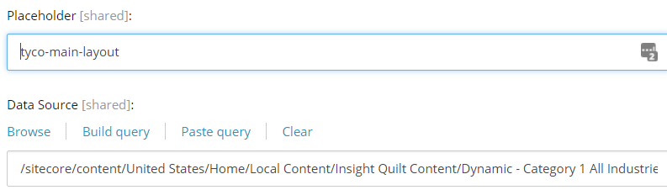

## Insight Quilt Static and Insight Quilt Static Slim Renderings

|  |  |
| --- | --- |
| **Rendering** | /sitecore/layout/Renderings/Feature/Insights/Insight Quilt Static/Insight Quilt Static  /sitecore/layout/Renderings/Feature/Insights/Insight Quilt Static/Insight Quilt Static Slim  /sitecore/layout/Renderings/Feature/Insights/Insight Quilt Static/Insight Quilt Static Card  Related Page Template: /sitecore/templates/Feature/Insights/Insight Article/_Insight Article |
| **Data Source** | /sitecore/templates/Feature/Insights/Insight Quilt Static/Insight Quilt Static |

### Create the Datasource

Create a new item from the **Insight Quilt Static** template.

The datasource controls the **Link**, **Link Text**, **Tile Color**, and **Description** on the left of the quilt.

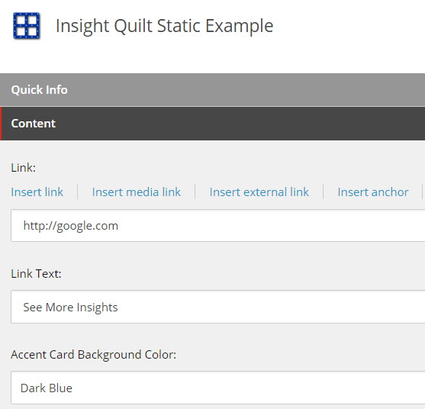

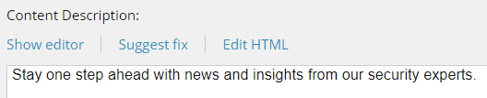



Additionally, for each other tile in the quilt, ensure that there is an existing page that inherits from the Insight Article template.

### Associate the content

Using either the experience editor or the presentation details menu, add an **Insight Quilt Static** or **Insight Quilt Static Slim** rendering to a page and then associate its datasource to the item you created earlier. The Slim rendering will have room for one card, whereas the regular rendering will have room for two.

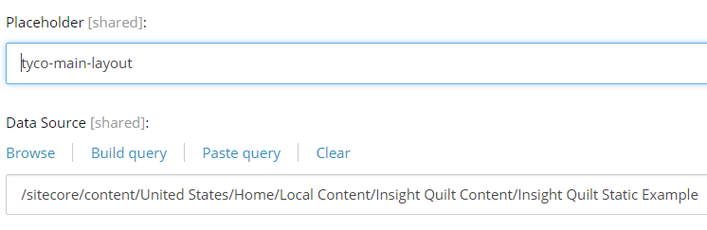

Depending on the rendering chosen above, add either one or two **Insight Quilt Static Card** renderings to the new placeholders and associate their datasources to the Insight Article items you want to highlight.

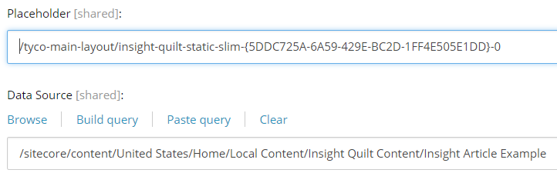



## Insight Rich Texts

|  |  |
| --- | --- |
| **Rendering** | /sitecore/layout/Renderings/Feature/Insights/Insight Rich Text/Insight Rich Text |
| **Data Source** | /sitecore/templates/Feature/Insights/Insight Rich Text/Insight Rich Text |

### Create the Datasource

Create a new item from the **Insight Rich Text** template. These control the text of the rendering.

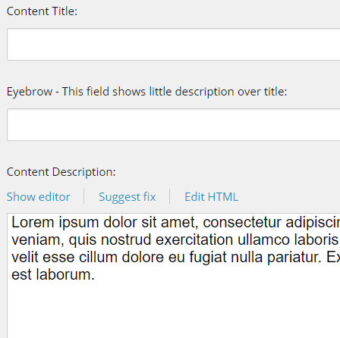

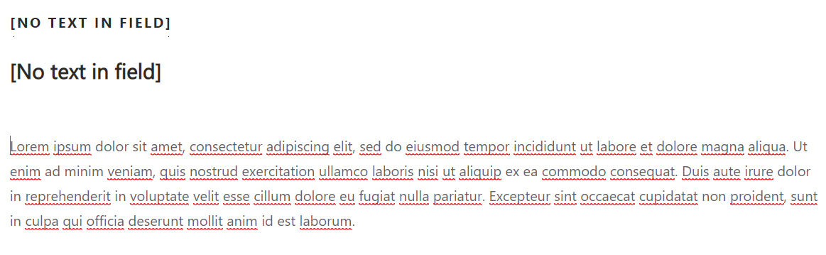

### Associate the content

Using either the experience editor or the presentation details menu, add an **Insight Rich Text** rendering to a page and then associate its datasource to the item you created earlier.

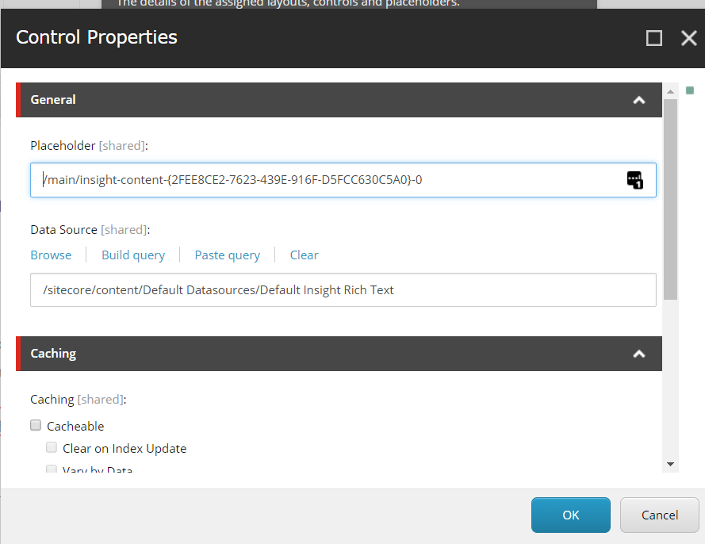

## Insight Sublayout

|  |  |
| --- | --- |
| **Rendering** | /sitecore/layout/Renderings/Feature/Insights/Insight Sublayout/Insight Sublayout |
| **Data Source** | None (Rendering exposes placeholders for other renderings) |

### Using the rendering

The Insight Sublayout uses no datasource and has no content. It exposes a region to add other insight renderings (the **insight-content** placeholder).

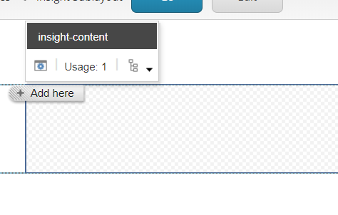

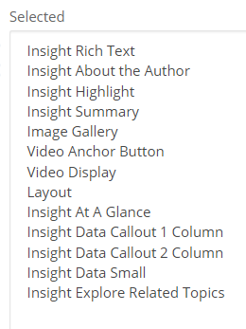

## Insight Summary

|  |  |
| --- | --- |
| **Rendering** | /sitecore/templates/Feature/Insights/Insight Summary/Insight Summary |
| **Data Source** | /sitecore/layout/Renderings/Feature/Insights/Insight Summary/Insight Summary |

### Create the Datasource

Create a new item from the **Insight Summary** template. The datasource controls the text in the summary.

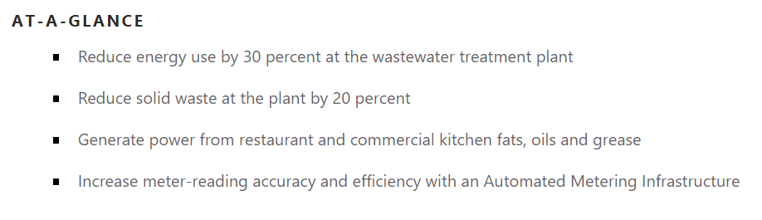

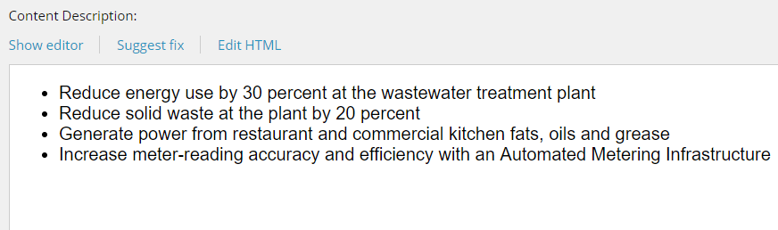

### Associate the content

Using either the experience editor or the presentation details menu, add a **Insight Summary** rendering to a page and then associate its datasource to the item you created earlier.

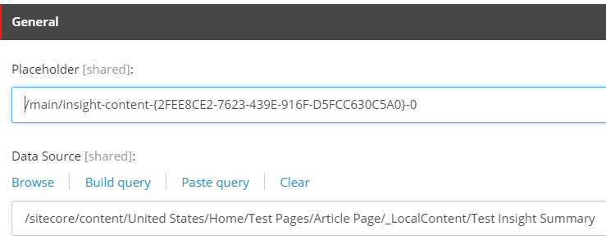

# Locations Feature

## Find a Location

|  |  |
| --- | --- |
| **Rendering** | /sitecore/layout/Renderings/Feature/Locations/Location Finder Callout/Find a Location |
| **Data Sources** | /sitecore/templates/Feature/Locations/Location Finder Callout/Location Finder Callout |

### Create the Datasource

Create a new item from the Location Finder Callout template. The datasource controls the text above the input.

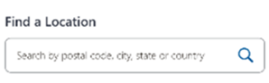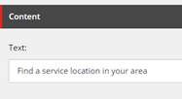

Additional settings that control the behavior itself are located on the Site Settings item, under the Location Finder Content section. These include simple toggles for whether to use Google or Bing, whether results should display distances in miles or kilometers, and a link to the results page.

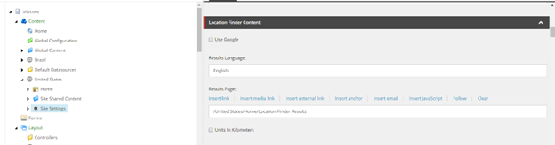

Additional text customization is available through dictionary entries at **/sitecore/content/Global Content/Dictionary/Feature/Locations**

### Associate the content

Using either the experience editor or the presentation details menu, add a Find a Location rendering to a page and then associate its datasource to the item you created earlier.

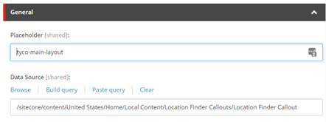

## Info Panel Location Finder Card

|  |  |
| --- | --- |
| **Rendering** | /sitecore/layout/Renderings/Feature/Locations/Location Finder Callout/Info Panel Location Finder Card |
| **Data Sources** | /sitecore/templates/Feature/Locations/Location Finder Callout/Info Panel Location Finder Card |

### Create the Datasource

Create a new item from the **Info Panel Location Finder Card** template. This controls the image and text above the input box.

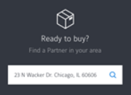

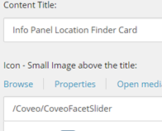

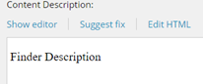

Additional text customization is available through dictionary entries at **/sitecore/content/Global Content/Dictionary/Feature/Locations**

### Associate the content

Using either the experience editor or the presentation details menu, add a **Info Panel Location Finder Callout** rendering to a page and then associate its datasource to the item you created earlier.

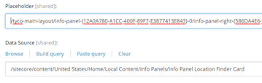

## Key Action Location Finder Callout Rendering

|  |  |
| --- | --- |
| **Rendering** | /sitecore/layout/Renderings/Feature/Locations/Location Finder Callout/Key Action Location Finder Callout |
| **Data Source** | /sitecore/templates/Feature/Locations/Location Finder Callout/Key Action Location Finder Callout |

### Create the Datasource

Create a new item from the **Key Action Location Finder Callout** template.

The datasource controls the text above the callout.

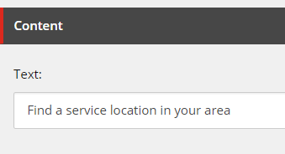

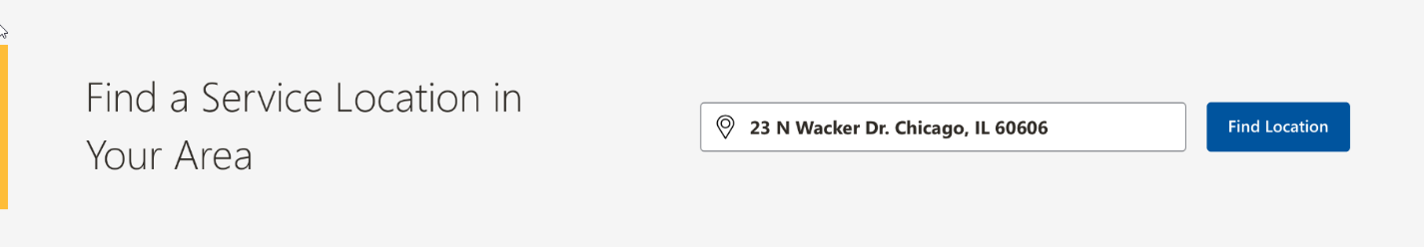

Additional settings that control the behavior itself are located on the **Site Settings** item, under the Location Finder Content section. These include simple toggles for whether to use Google or Bing, whether results should display distances in miles or kilometers, and a link to the results page.

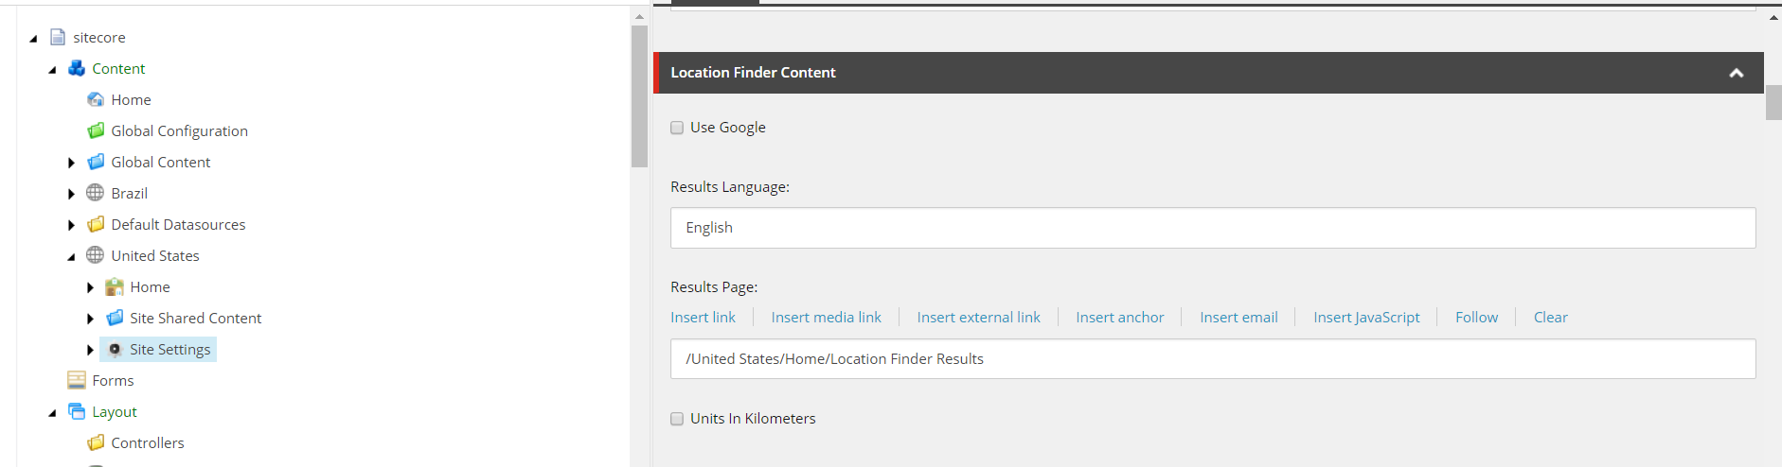

### Associate the content

Using either the experience editor or the presentation details menu, add a **Key Action Location Finder Callout** rendering to a page and then associate its datasource to the item you created earlier.

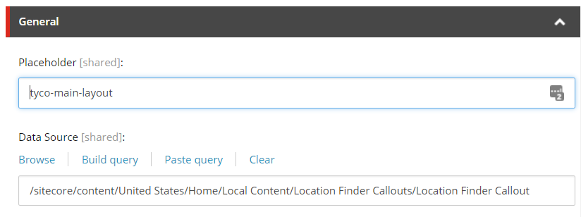

Additional text customization is available through dictionary entries at **/sitecore/content/Global Content/Dictionary/Feature/Locations**

## Local Page Detail

The Local Page Detail rendering does not take a datasource itself, but renders data belonging to the page it is placed on. The rendering looks for fields on a **Location Page**.

|  |  |
| --- | --- |
| **Rendering** | /sitecore/layout/Renderings/Feature/Locations/Local Page Detail/Local Page Detail |
| **Page Template** | /sitecore/templates/Feature/Locations/Location Page Detail/_Location Page Detail |

### Create the Page Data

Create a new item inheriting from the **_Location Page Detail** template. The specific name of the page template may vary by the site you are in.

The Template contains basic information for the location: Address, Phone, Business Hours, Crime Map, and other basic content

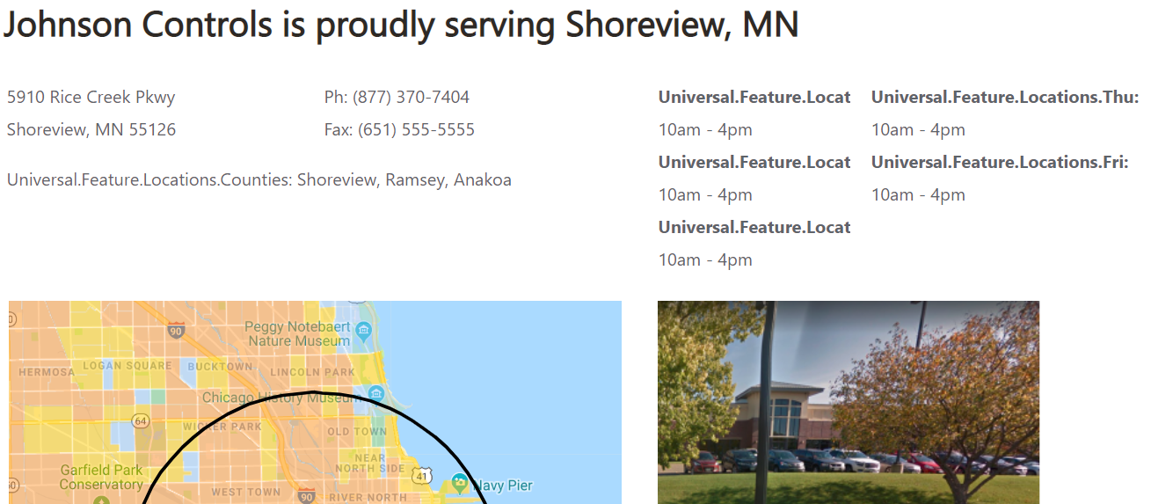

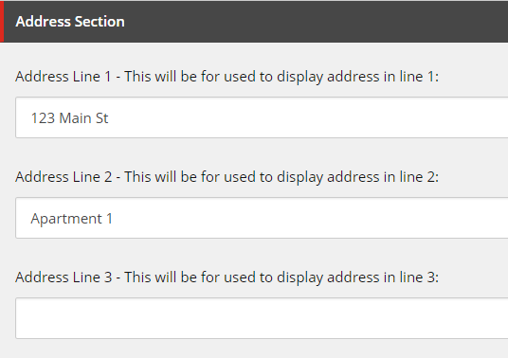

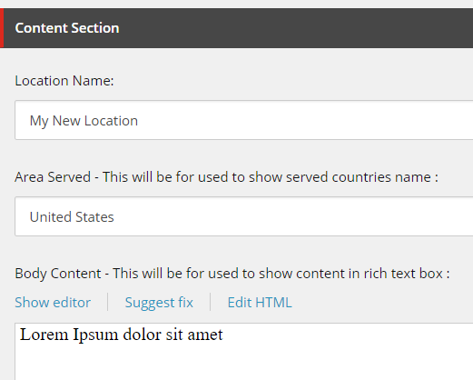

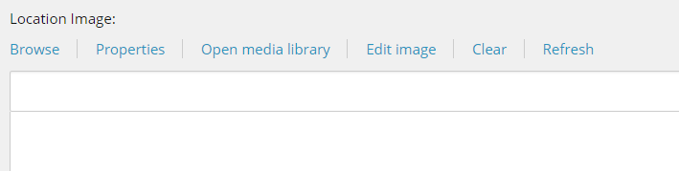

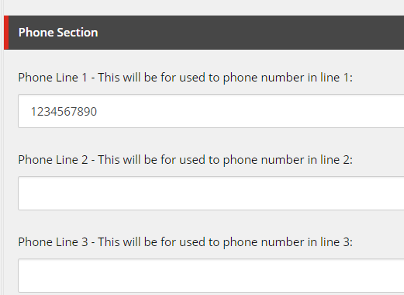

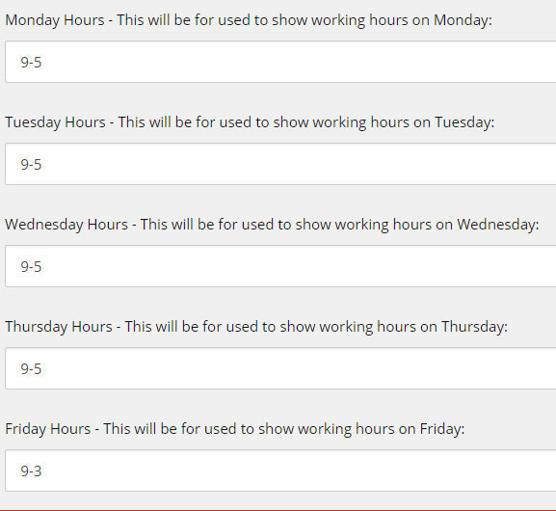

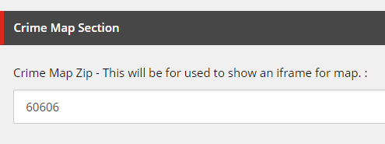

Additional text customization is available through dictionary entries at **/sitecore/content/Global Content/Dictionary/Feature/Locations**

### Associate the content

Using either the experience editor or the presentation details menu, add a **Universal Brand Grid Dynamic** rendering to a page and then associate its datasource to the item you created earlier.

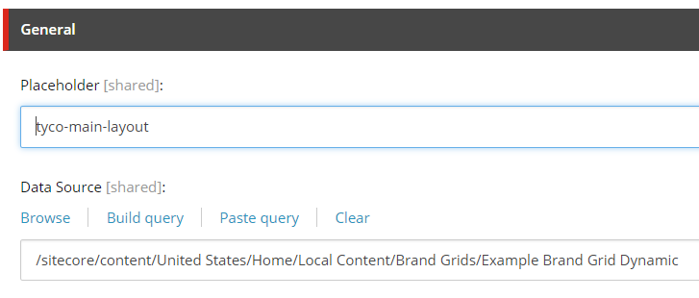

## Location Finder Callout Rendering (Partner Finder Callout)

|  |  |
| --- | --- |
| **Rendering** | /sitecore/layout/Renderings/Feature/Locations/Location Finder Callout/Universal Location Finder Callout |
| **Data Source** | /sitecore/templates/Feature/Locations/Location Finder Callout/Location Finder Callout |

### Create the Datasource

Create a new item from the **Location Finder Callout** template.

The datasource controls the text above the callout.

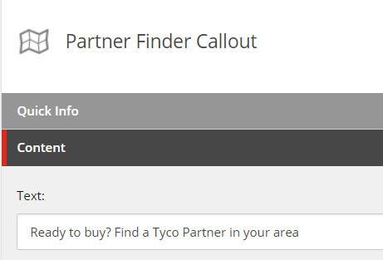

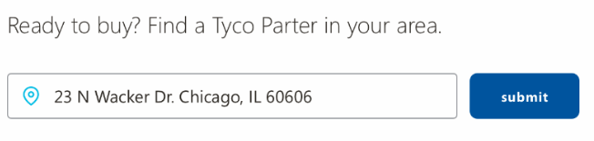

Additional settings that control the behavior itself are located on the **Site Settings** item, under the Location Finder Content section. These include simple toggles for whether to use Google or Bing, whether results should display distances in miles or kilometers, and a link to the results page.



### Associate the content

Using either the experience editor or the presentation details menu, add a **Universal Location Finder Callout** rendering to a page and then associate its datasource to the item you created earlier.



Additional text customization is available through dictionary entries at **/sitecore/content/Global Content/Dictionary/Feature/Locations**

## Location Finder Results Rendering

|  |  |
| --- | --- |
| **Rendering** | /sitecore/templates/Feature/Locations/Location Finder Callout/Location Finder Results |
| **Data Source** | /sitecore/layout/Renderings/Feature/Locations/Location Finder Callout/Universal Location Finder Results |

### Create the Datasource

Create a new item from the **Location Finder Results** template.

The datasource controls visual settings about the results page, like the Background Image.

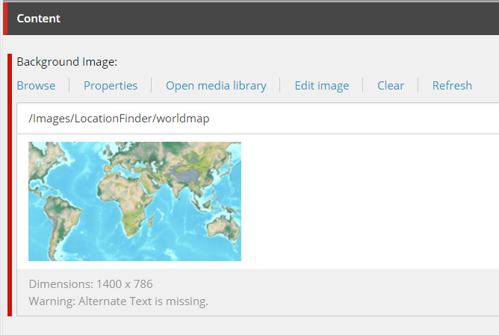

Additional settings that control the behavior itself are located on the **Site Settings** item, under the Location Finder Content section. These include simple toggles for whether to use Google or Bing, whether results should display distances in miles or kilometers, and the language of the results.

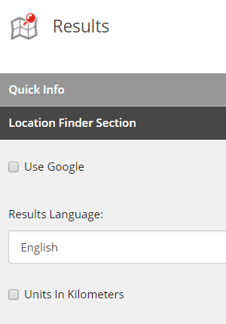

### Associate the content

Using either the experience editor or the presentation details menu, add a **Universal Location Finder Results** rendering to a page and then associate its datasource to the item you created earlier.

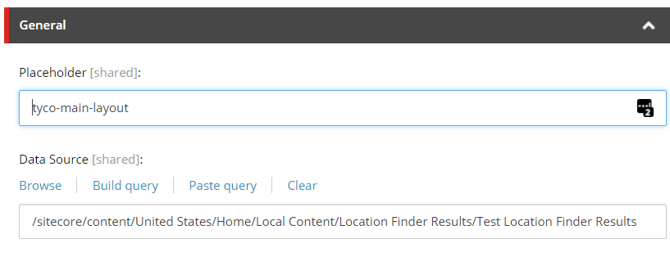

Additional text customization is available through dictionary entries at **/sitecore/content/Global Content/Dictionary/Feature/Locations**

# Navigation Feature

## Brand Grid Dynamic

|  |  |
| --- | --- |
| **Rendering** | /sitecore/layout/Renderings/Feature/Navigation/Brand Grid/Universal Brand Grid Dynamic |
| **Data Source** | /sitecore/templates/Feature/Navigation/Brand Grid/Brand Grid Dynamic |

### Create the Datasource

Create a new item from the **Brand Grid Dynamic** template.

The datasource controls the number and type of results to display, as well as some header text settings.

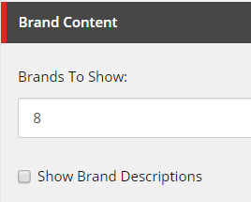

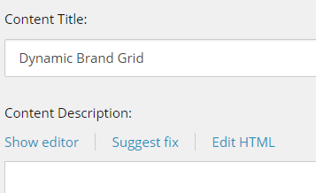

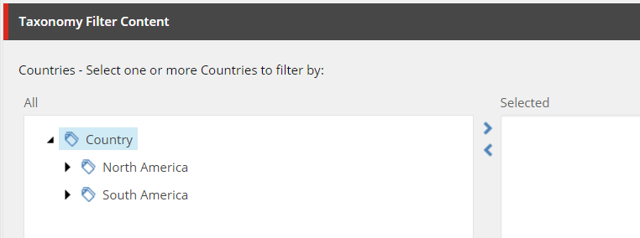

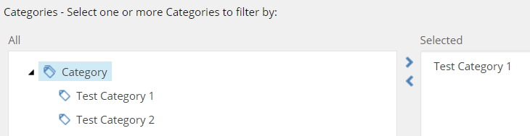

There are two fields to select tags for content: Countries and Categories. The brands shown must match one of the tags in each of those two fields, if they are populated. There will be as many results as the number specified, or all results if fewer than that number matched the tags.

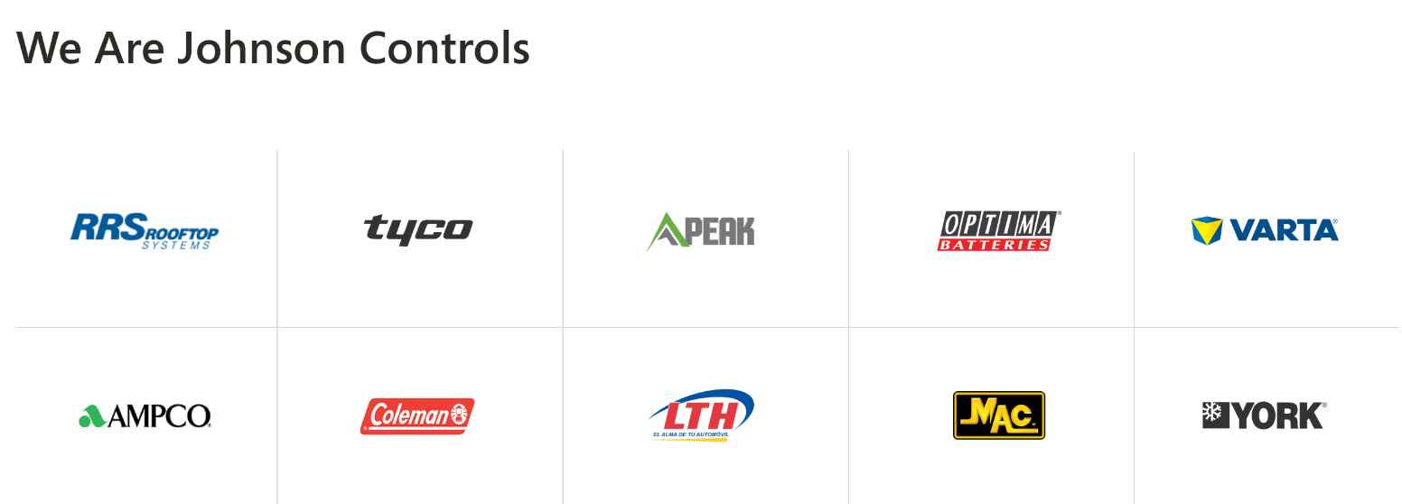

The column count will behave similarly to the static control:

In most cases, the brand icons will appear in five columns and will fill left-to-right. For fewer than nine brands selected, the number of columns is adjusted:

If 1 logo, show 3 column, put in first

If 2 logos, show 3 column, put in first and second

If 4 logos, show 4 columns,

If 5 logos, show 5 columns,

If 6 logos, show 2 rows of 3,

If 7 logos, show 2 rows of 4, (minus 1)

If 8 logos, show 2 rows of 4

### Associate the content

Using either the experience editor or the presentation details menu, add a **Universal Brand Grid Dynamic** rendering to a page and then associate its datasource to the item you created earlier.



## Brand Grid Static

|  |  |
| --- | --- |
| **Rendering** | /sitecore/layout/Renderings/Feature/Navigation/Brand Grid/Universal Brand Grid Static |
| **Data Source** | /sitecore/templates/Feature/Navigation/Brand Grid/Brand Grid Static |

### Create the Datasource

Create a new item from the **Brand Grid Static** template.

The datasource controls the number and type of results to display, as well as some header text settings.

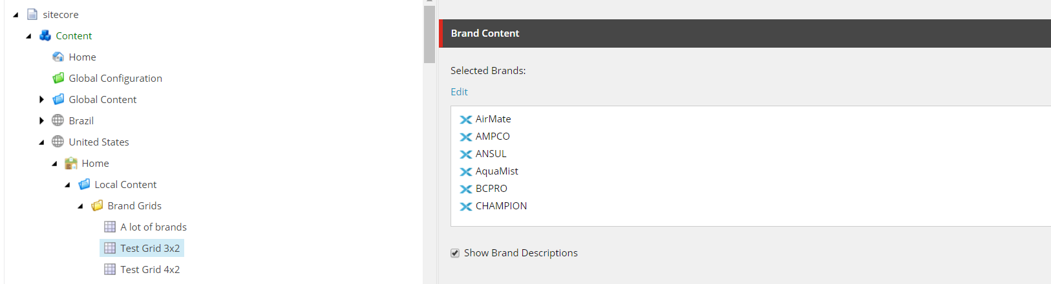

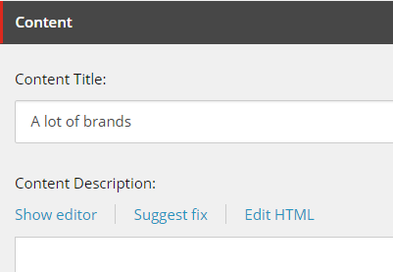

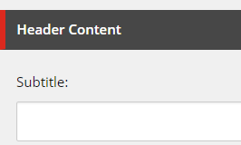



In most cases, the brand icons will appear in five columns and will fill left-to-right. For fewer than nine brands selected, the number of columns is adjusted:

If 1 logo, show 3 column, put in first

If 2 logos, show 3 column, put in first and second

If 4 logos, show 4 columns,

If 5 logos, show 5 columns,

If 6 logos, show 2 rows of 3,

If 7 logos, show 2 rows of 4, (minus 1)

If 8 logos, show 2 rows of 4

### Associate the content

Using either the experience editor or the presentation details menu, add a **Universal Brand Grid Dynamic** rendering to a page and then associate its datasource to the item you created earlier.

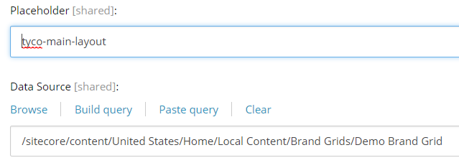

## Brand Grid with Description

|  |  |
| --- | --- |
| **Rendering** | /sitecore/layout/Renderings/Feature/Navigation/Brand Grid With Description/Brand Grid With Description |
| **Data Source** | /sitecore/templates/Feature/Navigation/Brand Grid With Description/Brand Grid With Description  /sitecore/templates/Feature/Navigation/Brand Grid With Description/Brand Item |

### Create the Datasource

Create a new item from the **Brand Grid with Description** template.

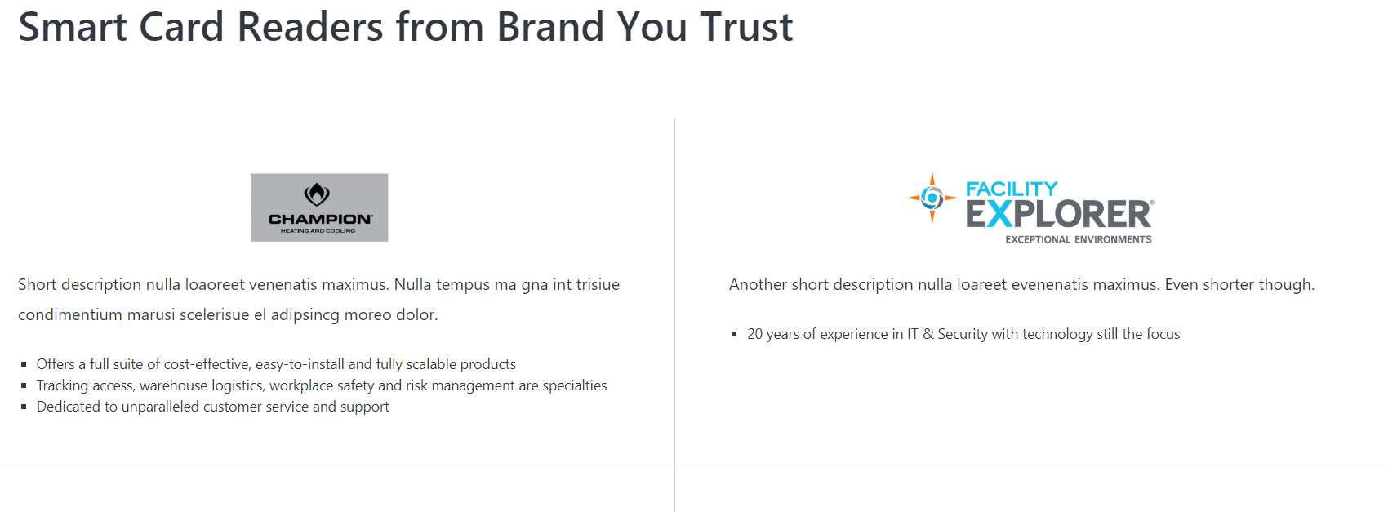

The parent item controls the title and the background color.

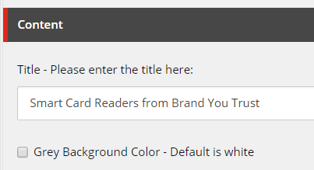

For each brand you want to display in the gird, insert a **Brand Item** as a child.

In the selected Brand field, choose the brand to display. By default, the gird will show the Brand’s Logo, Blurb, and then the Description.

However, if you want a different blurb or description than is defined on your Selected Brand, you can populate the Brand Blurb Overrider Content and the Brand Description Override Content fields, and then check the boxes to use the overrides instead of the default content.

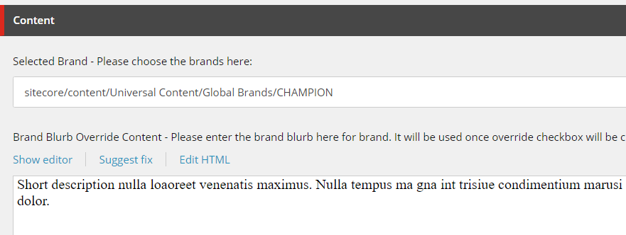

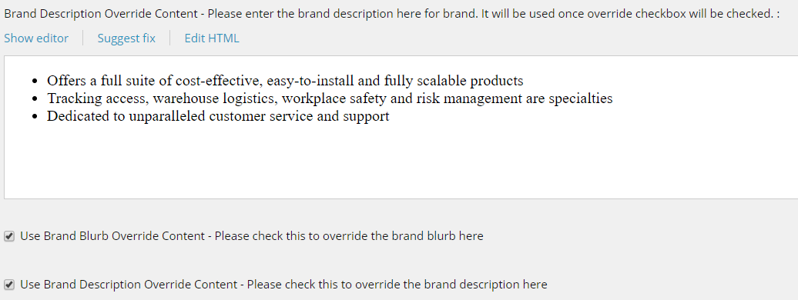

### Associate the content

Using either the experience editor or the presentation details menu, add a **Brand Grid with Description** rendering to a page and then associate its datasource to the item you created earlier.

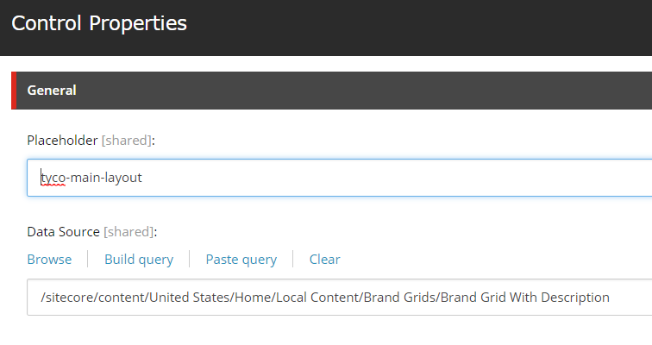

## Breadcrumb

The breadcrumb rendering does not take a datasource, but it looks for content on the page it is placed on, and on that page’s ancestors.

|  |  |
| --- | --- |
| **Rendering** | /sitecore/layout/Renderings/Feature/Navigation/Breadcrumb/Universal Breadcrumb |
| **Page Templates** | /sitecore/templates/Feature/Navigation/Navigation Page Settings/_Navigation Page Settings  /sitecore/templates/Foundation/Page Metadata/_PageMetadata (To check if an item is a page) |

### Update your page

Create a new page item and ensure that it inherits from the above two page base templates. Most page templates should inherit from them by default.

Scroll down to the Navigation section. These fields allow you to modify what name this page should display in the breadcrumb, and whether the page should display a breadcrumb itself.

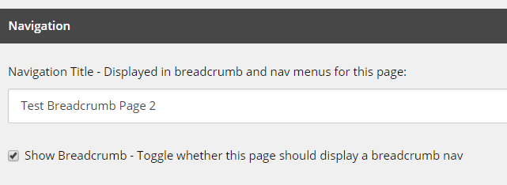

Once that is done, go to the item’s parent and make the same changes there to ensure that the breadcrumb displays the pages as desired.

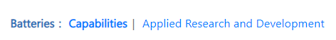

If a parent of an item is not a page (for example, if it’s a folder) it will never display in the breadcrumb. The breadcrumb always ends at the home page.

### Associate the content

Using either the experience editor or the presentation details menu, add a **Breadcrumb** rendering to the page you edited earlier. Take note that most page template standard values will include a breadcrumb by default, so you should ensure that the field to display the breadcrumb is checked and see if there is one already on the page before you try to add one.

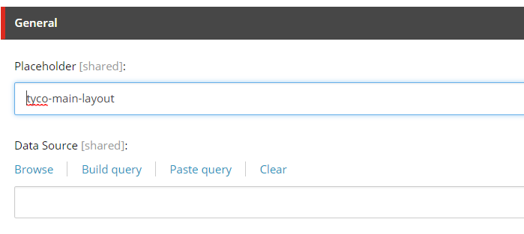

## Cookie Disclaimer

|  |  |
| --- | --- |
| **Rendering** | /sitecore/layout/Renderings/Feature/Navigation/Cookie Disclaimer/Cookie Disclaimer |
| **Data Source (from Site Settings)** | /sitecore/templates/Feature/Navigation/Cookie Disclaimer/_CookieDisclaimerSiteSettings |

### Edit the Site content

The Cookie Disclaimer doesn’t use a datasource or page content, and instead gets its content from the Site Settings item.

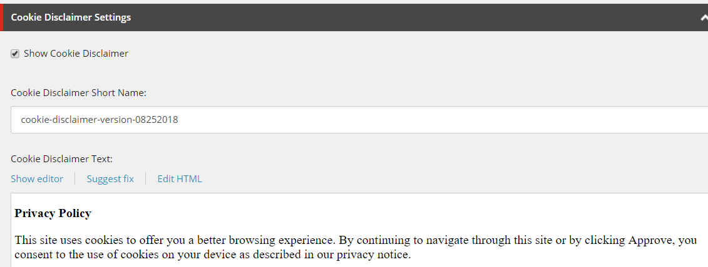

The rendering will not display if the box is unchecked, and it will only display until the user clicks the accept button.

The short name is used by the browser to track whether the user has accepted. If you update the content and need to show the new disclaimer to all users regardless of whether they have accepted in the past, you should also update the short name so that the browser knows to ignore their previous acceptance.

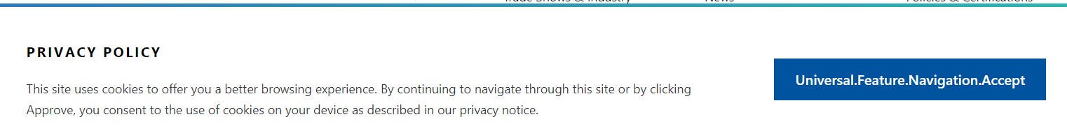

Additional text customization is available through dictionary entries at **/sitecore/content/Global Content/Dictionary/Feature/Navigation**

### Associate the content

Most page templates already have a **Cookie Disclaimer** rendering in their standard values. Ensure that the site settings are set to show Cookie Disclaimers before attempting to add one. If there isn’t one on the page and the settings are set to show, you can add one using either the experience editor or the presentation details menu.

## Gated Content Modal

|  |  |
| --- | --- |
| **Rendering** | /sitecore/layout/Renderings/Feature/Navigation/Gated Content/Gated Content |
| **Data Sources** | /sitecore/templates/Feature/Navigation/Gated Content/_GatedContentSiteSettings (Site settings)  /sitecore/templates/Feature/Navigation/Gated Content/_GatedContentPageSettings (Page Settings) |

### Set the gated content data

The gated content rendering does not use a data source, but instead uses data from the Site Settings, and settings on the page it’s placed on.

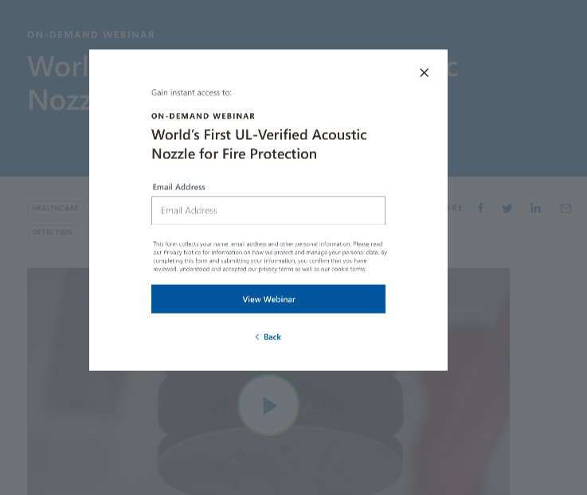

The content of the modal is defined in site settings. You can set a reference to a Sitecore form and specify additional text.

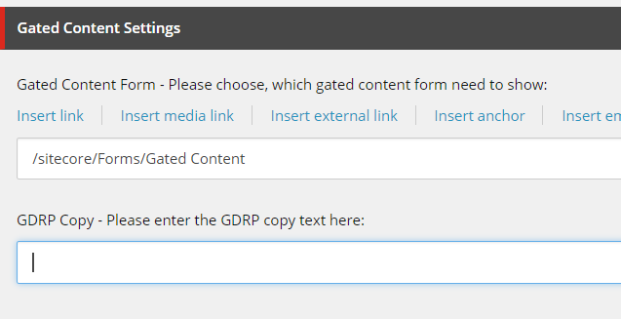

The behavior of the modal is defined on the page level. You can check the “Gate Content” box if the page should show the modal, and you can specify additional text.

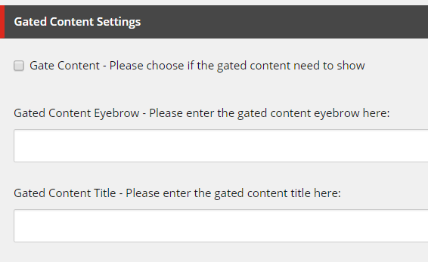

Additional text customization is available through dictionary entries at **/sitecore/content/Global Content/Dictionary/Feature/Navigation**

### Associate the content

Most page templates include a **Gated Content** rendering already. Make sure that the page is set to display it and that you have the content set through site settings before you add one. Once you’ve ensured that there isn’t one already, you can add the rendering through Presentation Details or Experience Editor.

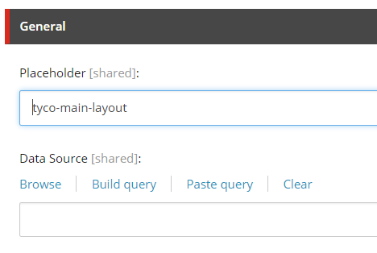

## Global Alerts Banner

|  |  |
| --- | --- |
| **Rendering** | /sitecore/layout/Renderings/Feature/Navigation/Global Alert/Global Alert |
| **Data Source** | /sitecore/templates/Feature/Navigation/Global Alerts/_GlobalAlertSiteSettings |

### Edit the Site content

The Global Alert Banner doesn’t use a datasource or page content, and instead gets its content from the Site Settings item.

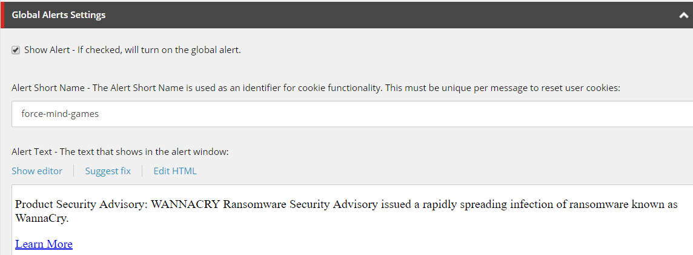

The rendering will not display if the box is unchecked, and it will only display until the user clicks the accept button.

The short name is used by the browser to track whether the user has closed this alert. If you update the content and need to show the new banner to all users regardless of whether they have closed the banner alert in the past, you should also update the short name.



Additional text customization is available through dictionary entries at **/sitecore/content/Global Content/Dictionary/Feature/Navigation**

### Associate the content

Most page templates already have a **Global Alert** rendering in their standard values. Ensure that the site settings are set to show alerts before attempting to add one. If there isn’t one on the page and the settings are set to show, you can add one using either the experience editor or the presentation details menu.

# Footer Renderings

## Footer

|  |  |
| --- | --- |
| Datasource Template | /sitecore/templates/Feature/Navigation/Footer/Footer |
| Datasource Location | /sitecore/content/<Site>/Site Shared Content/Site Footers |
| Rendering | *Multiple* |

### Prerequisites

The following items must be present in Sitecore to complete the steps described below:

1. /sitecore/content/<Site>/Site Shared Content/Site Footers

2. /sitecore/content/<Site>/Site Settings

### Appearance

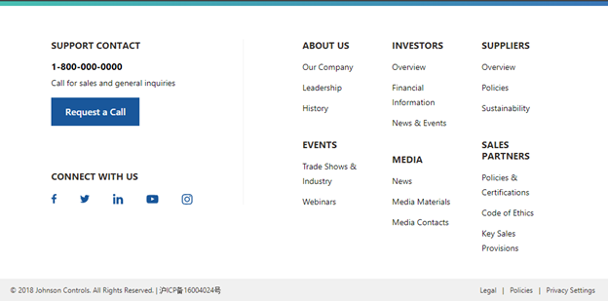

Figure 1 - Footer Option 1 - Two Rows - 5x7 and 4x4x4

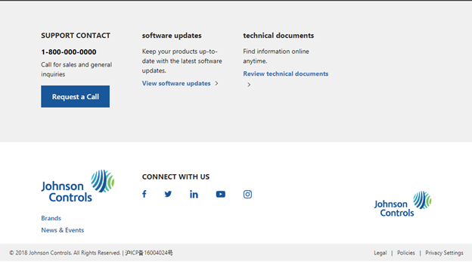

Figure 2 - Footer Option 2 - Two Rows - 3x3x3x3 and 3x6x3

### Create the Datasource

1. Login to Sitecore

2. Open the **Content Editor**

3. Expand **Content**

4. Expand the Site under which you want to create the new Footer

5. Expand **Site Shared Content**

6. Right-click **Site Footer**

7. Click **Insert**

8. Click on one of the two Footer options

9. Enter the name of the item and click the **OK** button

### Create the content

#### Universal Menu Link List

One of the components you can add to the Footer is the **Universal Menu Link List**. To add this component to the Footer, you need to first create the content for this component. Follow the steps in the **JCI - Content Author Reference Doc - Universal Menu Link List** document to create the content for your **Universal Menu Link List** components.

#### Legal Bar

Another component you can add to the Footer is the **Legal Bar**. Follow the same steps as the **Universal Menu Link List** to create the content for the **Legal Bar**.

#### Social Media Callout

Another component you can add to the Footer is the Social Media Callout. Follow the same steps as the Universal Menu Link List to create the content for the Social Media Callout.

Now that you’ve created all of your content, you need to add components to the Footer and associate them with your link lists. During this time, you will also add other components to your Footer and create additional content.

1. Click on the Footer item you created a few steps above

2. Go to the **Publish** tab

3. Click **Experience Editor**

The Footer item will open in the Sitecore Experience Editor.



4. Click **Lock and Edit**

You will now see placeholders for each section of the Footer where you can add components.



To add components to a placeholder:

1. Click anywhere inside the placeholder

2. Click the **+ Add here** button that displays in the top-level of the placeholder

3. Select the component you want to add

4. Click the **Select** button

5. Either select an existing content item from the list on the right or click **Create New Content**

* 1. If you clicked **Create New Content**, enter the name of the item and click the **OK** button

Repeat steps 1 through 5 above for each component you desire to add to the menu.

Once you’ve added all of your components to the menu, click the **Save** button in the top-left.

#### Set the default Footer

Now that you’ve created the new **Footer**, you have to set it as the “default” Footer for your site(s).

1. Go to the **Site Settings** item for your site(s)

2. In the **Default Footer** field, select the new Footer you created in the above steps

3. Save the item

#### Preview the Home page

Preview the Home page for the Site in which you set the new Header. Your new Footer will display at the bottom of the page.

#### Update an existing Footer

1. Login to Sitecore

2. Open the **Content Editor**

3. Expand **Content**

4. Expand the Site under which you want to create the new Footer

5. Expand **Site Shared Content**

6. Expand **Site Footers**

7. Click on the Footer you want to update

* 1. If you want to edit the content that was previously created
  2. Go to the **Publish** tab
  3. Click **Experience Editor**
  4. Update the content as desired
  5. Save the item

1. If you want to create new content or delete content that was previously created
   1. Follow the steps in section 1.4 Create the content